“Data Warehousing”: Source code

-Heena Rijhwani

**Loading initial data downloaded from kaggle into tables**

--Creating Table Customer

CREATE TABLE CUSTOMER

(

CUSTOMER_ID VARCHAR(50),

CUSTOMER_UNIQUE_ID VARCHAR(50),

ZIPCODE NUMERIC(16),

CUSTOMER_CITY VARCHAR(50),

CUSTOMER_STATE VARCHAR(10),

CONSTRAINT CustomerId_PK PRIMARY KEY (Customer_Id) --customer id is the unique PK here

);

--Inserting data into table from the csv file

COPY Customer(Customer_Id,Customer_Unique_Id,Zipcode,Customer_City,Customer_State)

FROM 'C:\Users\heena\OneDrive\Desktop\CS 779\Project\data\olist_customers_dataset.csv'

DELIMITER ','

CSV HEADER;

--Retrieving data from table to check if it has been loaded

Select * from Customer limit 5;

--Creating table Order Items

CREATE TABLE ORDER_ITEMS

(

ORDER_ID VARCHAR(50),

ORDER_ITEM_NUM INTEGER, --number of items per order

PRODUCT_ID VARCHAR(50),

SELLER_ID VARCHAR(50),

SHIPPING_DATE TIMESTAMP,

PRICE VARCHAR(50),

FREIGHT_VALUE VARCHAR(50) --transportation cost per item in order

);

--Inserting data into table from the csv file

COPY Order_items(Order_Id,Order_Item_num,Product_id,Seller_id,Shipping_date,Price,Freight_value)

FROM 'C:\Users\heena\OneDrive\Desktop\CS 779\Project\data\olist_order_items_dataset.csv'

DELIMITER ','

CSV HEADER;

--Retrieving to check results

Select * from Order_items limit 5;

--Creating table Order Payments

CREATE TABLE ORDER_PAYMENTS

(

ORDER_ID VARCHAR(50),

PAYMENT_SEQUENTIAL INTEGER, --maps to payment method of each installment

PAYMENT_TYPE VARCHAR(50),

PAYMENT_INSTALLMENTS INTEGER, --number of installments

PAYMENT_VALUE FLOAT

);

--Inserting data into table from the csv file

COPY Order_payments(Order_Id,payment_sequential,payment_type,payment_installments,payment_value)

FROM 'C:\Users\heena\OneDrive\Desktop\CS 779\Project\data\olist_order_payments_dataset.csv'

DELIMITER ','

CSV HEADER;

--Retrieving to check if data has been loaded

Select * from Order_payments limit 5;

--Creating table Order_reviews

CREATE TABLE ORDER_REVIEWS

(

REVIEW_ID VARCHAR(50),

ORDER_ID VARCHAR(50),

REVIEW_SCORE INTEGER, --1 to 5 rating

REVIEW_COMMENT_TITLE TEXT,

REVIEW_COMMENT_MESSAGE TEXT,

REVIEW_CREATION_DATE TIMESTAMP,

REVIEW_ANSWER_TIMESTAMP TIMESTAMP

);

--Inserting data into table from the csv file

COPY Order_reviews(Review_Id,Order_Id,review_score,review_comment_title,review_comment_message,review_creation_date,review_answer_timestamp)

FROM 'C:\Users\heena\OneDrive\Desktop\CS 779\Project\data\olist_order_reviews_dataset.csv'

DELIMITER ','

CSV HEADER;

--Creating Orders table

CREATE TABLE ORDERS

(

ORDER_ID VARCHAR(50),

CUSTOMER_ID VARCHAR(50),

ORDER_STATUS VARCHAR(50),

ORDER_PURCHASE_TIMESTAMP TIMESTAMP,

ORDER_APPROVED_AT TIMESTAMP,

ORDER_DELIVERED_CARRIER_DATE TIMESTAMP,

ORDER_DELIVERED_CUSTOMER_DATE TIMESTAMP,

ORDER_ESTIMATED_DELIVERY_DATE TIMESTAMP

);

--Inserting data into table from the csv file

COPY Orders(Order_Id,rcustomer_id,order_status,order_purchase_timestamp,aorder_approved_at,order_delivered_carrier_date,order_delivered_customer_date,order_estimated_delivery_date)

FROM 'C:\Users\heena\OneDrive\Desktop\CS 779\Project\data\olist_orders_dataset.csv'

DELIMITER ','

CSV HEADER;

--Retrieving to check results

Select * from Orders limit 5;

--Creating products table

CREATE TABLE PRODUCTS

(

PRODUCT_ID VARCHAR(50),

PRODUCT_CATEGORY_NAME TEXT,

PRODUCT_NAME_LENGHT INTEGER,

PRODUCT_DESCRIPTION_LENGHT INTEGER,

PRODUCT_PHOTOS_QTY INTEGER,

PRODUCT_WEIGHT_G INTEGER,

PRODUCT_LENGHT_CM INTEGER,

PRODUCT_HEIGHT_CM INTEGER,

PRODUCT_WIDTH_CM INTEGER

);

--Inserting data into table from the csv file

COPY Products(product_id,product_category_name,product_name_length,product_description_length,product_photos_qty, product_weight_g,product_length_cm,product_height_cm,product_width_cm)

FROM 'C:\Users\heena\OneDrive\Desktop\CS 779\Project\data\olist_products_dataset.csv'

DELIMITER ','

CSV HEADER;

--Retrieving to check results

Select * from Products limit 5;

--Creating Sellers table

CREATE TABLE SELLERS

(

SELLER_ID VARCHAR(50),

ZIPCODE NUMERIC(16),

SELLER_CITY VARCHAR(50),

SELLER_STATE VARCHAR(50)

);

--Inserting data into table from the csv file

COPY Sellers(Seller_id,zipcode,seller_city,seller_state)

FROM 'C:\Users\heena\OneDrive\Desktop\CS 779\Project\data\olist_sellers_dataset.csv'

DELIMITER ','

CSV HEADER;

--Retrieving to check results

Select * from Sellers;

**Adding constraints to these tables**

Primary Key constraints

--Adding synthetic PK to Order_items table using Serial

ALTER TABLE order_items

ADD COLUMN Order_item_id SERIAL PRIMARY KEY;

Select * from order_items limit 2;

--Adding synthetic PK to Payments table using Sequence

ALTER TABLE order_payments

ADD COLUMN Order_payments_id INTEGER;

CREATE SEQUENCE payment_id_seq AS INT INCREMENT BY 1 START WITH 1 OWNED BY order_payments.order_payments_id;

ALTER TABLE order_payments ALTER COLUMN Order_payments_id SET DEFAULT nextval('payment_id_seq');

UPDATE order_payments SET order_payments_id = nextval('payment_id_seq');

Select * from Order_payments limit 2;

--Adding PK constraint for Order_reviews

ALTER TABLE order_reviews

ADD PRIMARY KEY (review_id,order_id);--composite PK

--Adding PK constraint for Orders

ALTER TABLE orders

ADD PRIMARY KEY (order_id);--setting order id attribute as PK

--Adding PK constraint for Products

ALTER TABLE products

ADD PRIMARY KEY (product_id);--setting order id attribute as PK

Adding Foreign Key constraints to link all entities

ALTER TABLE order_items

ADD CONSTRAINT order_id_fk FOREIGN KEY (order_id) REFERENCES Orders(order_id);

ALTER TABLE order_items

ADD CONSTRAINT product_id_fk FOREIGN KEY (product_id) REFERENCES Products(product_id);

ALTER TABLE order_items

ADD CONSTRAINT seller_id_fk FOREIGN KEY (seller_id) REFERENCES Sellers(seller_id);

ALTER TABLE orders

ADD CONSTRAINT customer_id_fk FOREIGN KEY (customer_id) REFERENCES Customer(customer_id);

ALTER TABLE order_payments

ADD CONSTRAINT order_id_fk2 FOREIGN KEY (order_id) REFERENCES Orders(order_id);

ALTER TABLE order_reviews

ADD CONSTRAINT order_id_fk3 FOREIGN KEY (order_id) REFERENCES Orders(order_id);

**Normalizing the schema**

--Creating a separate table for **payment methods**

--Mapping each unique method to an id

Create table payment_method(

payment_method_id integer primary key,

payment_type varchar(50));

Insert into payment_method

values(1,'credit_card');

Insert into payment_method

values(2,'boleto');

Insert into payment_method

values(3,'voucher');

Insert into payment_method

values(4,'debit_card');

Insert into payment_method

values(5,'not_defined');

--Creating new normalized table (I.e. replacing payment type by payment method id)

Create table order_payment(

ORDER_ID VARCHAR(50),

PAYMENT_SEQUENTIAL INTEGER, --maps to payment method of each installment

PAYMENT_METHOD_ID INTEGER,

PAYMENT_INSTALLMENTS INTEGER, --number of installments

PAYMENT_VALUE FLOAT

);

--Inserting values in new normalized table

INSERT INTO order_payment(order_id,payment_sequential,payment_installments,payment_value,payment_method_id)

Select o.order_id,o.payment_sequential,o.payment_installments,o.payment_value,p.payment_method_id

from order_payments o

Full join payment_method p on p.payment_type = o.payment_type; --using full join to get rows from both tables

--Similarly adding synthetic PK to new Payment table using Sequence

ALTER TABLE order_payment

ADD COLUMN Order_payments_id INTEGER;

CREATE SEQUENCE payment_id_seq AS INT INCREMENT BY 1 START WITH 1 OWNED BY order_payment.order_payments_id;

ALTER TABLE order_payment ALTER COLUMN Order_payments_id SET DEFAULT nextval('payment_id_seq');

UPDATE order_payment SET order_payments_id = nextval('payment_id_seq');

Select * from Order_payment limit 2;

--Again add FK constraint (order id which references Order table) to new normalized payment table

ALTER TABLE order_payment

ADD CONSTRAINT order_id_fk3 FOREIGN KEY (order_id) REFERENCES Orders(order_id);

--Also adding FK constraint to payment_method_id which references payment method table we just created

ALTER TABLE order_payment

ADD CONSTRAINT payment_method_id_fk FOREIGN KEY (payment_method_id) REFERENCES Payment_method(payment_method_id);

--Similarly normalizing **Order_status**

Create table order_status(

Order_status_id integer primary key,

Order_status varchar(50));

Insert into order_status

values(1,'delivered');

Insert into order_status

values(2,'invoiced');

Insert into order_status

values(3,'shipped');

Insert into order_status

values(4,'processing');

Insert into order_status

values(5,'unavailable');

Insert into order_status

values(6,'canceled’');

Insert into order_status

values(7,'created');

Insert into order_status

values(8,'approved');

--Creating new normalized table

Create table order2(

ORDER_ID VARCHAR(50),

CUSTOMER_ID VARCHAR(50),

ORDER_STATUS_ID INTEGER, --replacing order status by status id

ORDER_PURCHASE_TIMESTAMP TIMESTAMP,

ORDER_APPROVED_AT TIMESTAMP,

ORDER_DELIVERED_CARRIER_DATE TIMESTAMP,

ORDER_DELIVERED_CUSTOMER_DATE TIMESTAMP,

ORDER_ESTIMATED_DELIVERY_DATE TIMESTAMP

);

--Inserting values in new normalized table by joining 2 tables (old Orders table and new Order_status table mapping each status to an id)

INSERT INTO order2(order_id,customer_id,order_status_id,order_purchase_timestamp,order_approved_at,order_delivered_carrier_date,order_delivered_customer_date,order_estimated_delivery_date)

Select o.order_id,o.customer_id,o2.order_status_id,o.order_purchase_timestamp,o.order_approved_at,o.order_delivered_carrier_date,o.order_delivered_customer_date,o.order_estimated_delivery_date

from orders o

Full join order_status o2 on o.order_status = o2.order_status;

--Adding constraints to new normalized table

ALTER TABLE order2

ADD PRIMARY KEY (order_id);

ALTER TABLE order2

ADD CONSTRAINT customer_id_fk2 FOREIGN KEY (customer_id) REFERENCES Customer(customer_id);

ALTER TABLE order2

ADD CONSTRAINT order_status_id_fk FOREIGN KEY (order_status_id) REFERENCES Order_status(order_status_id);

--Also re-adding FK constraints on other entities which reference the Orders table (since I created a new normalized Orders table)

--ALTER TABLE order_reviews

ADD CONSTRAINT order_id_fk4 FOREIGN KEY (order_id) REFERENCES order2(order_id);

--ALTER TABLE order_items

ADD CONSTRAINT order_id_fk5 FOREIGN KEY (order_id) REFERENCES order2(order_id);

--ALTER TABLE order_payment

ADD CONSTRAINT order_id_fk6 FOREIGN KEY (order_id) REFERENCES order2(order_id);

--Similarly normalizing **product category**

--Creating and inserting values into new category table which maps each name to an id

Create table category(

category_id integer primary key,

product_category_name text);

Insert into category

values(1,'perfumaria');

Insert into category

values(2,'artes');

Insert into category

values(3,'esporte_lazer');

Insert into category

values(4,'bebes');

Insert into category

values(5,'utilidades_domesticas');

Insert into category

values(6,instrumentos_musicais');

Insert into category

values(7,'cool_stuff');

Insert into category

values(8,moveis_decoracao');

Insert into category

values(9,'eletrodomesticos');

Insert into category

values(10,'brinquedos');

Insert into category

values(11,'cama_mesa_banho');

Insert into category

values(12,'construcao_ferramentas_seguranca');

Insert into category

values(13,'informatica_acessorios');

Insert into category

values(14,'beleza_saude');

Insert into category

values(15,'malas_acessorios');

Insert into category

values(16,'ferramentas_jardim');

Insert into category

values(17,'moveis_escritorio');

Insert into category

values(18,’automotivo');

Insert into category

values(19,'eletronicos');

Insert into category

values(20,'fashion_calcados');

Insert into category

values(21,'telefonia');

Insert into category

values(22,'papelaria');

Insert into category

values(23,'fashion_bolsas_e_acessorios');

Insert into category

values(24,'pcs');

Insert into category

values(25,'casa_construcao');

Insert into category

values(26,'relogios_presentes');

Insert into category

values(27,'construcao_ferramentas_construcao');

Insert into category

values(28,'pet_shop');

Insert into category

values(29,’eletroportateis');

Insert into category

values(30,’agro_industria_e_comercio');

Insert into category

values(31,'moveis_sala');

Insert into category

values(32,'sinalizacao_e_seguranca');

Insert into category

values(33,'climatizacao');

Insert into category

values(34,'consoles_games');

Insert into category

values(35,'livros_interesse_geral');

Insert into category

values(36,'construcao_ferramentas_ferramentas');

Insert into category

values(37,'fashion_underwear_e_moda_praia');

Insert into category

values(38,'fashion_roupa_masculina');

Insert into category

values(39,'moveis_cozinha_area_de_servico_jantar_e_jardim');

Insert into category

values(40,’industria_comercio_e_negocios');

Insert into category

values(41,’telefonia_fixa');

Insert into category

values(42,'construcao_ferramentas_iluminacao');

Insert into category

values(43,'livros_tecnicos');

Insert into category

values(44,'eletrodomesticos_2');

Insert into category

values(45,'artigos_de_festas');

Insert into category

values(46,'bebidas');

Insert into category

values(47,'market_place');

Insert into category

values(48,'la_cuisine');

Insert into category

values(49,'construcao_ferramentas_jardim');

Insert into category

values(50,'fashion_roupa_feminina');

Insert into category

values(51,’casa_conforto');

Insert into category

values(52,’audio');

Insert into category

values(53,'alimentos_bebidas');

Insert into category

values(54,'musica');

Insert into category

values(55,'alimentos');

Insert into category

values(56,'tablets_impressao_imagem');

Insert into category

values(57,'livros_importados');

Insert into category

values(58,'portateis_casa_forno_e_cafe');

Insert into category

values(59,'fashion_esporte');

Insert into category

values(60,'artigos_de_natal');

Insert into category

values(61,'fashion_roupa_infanto_juvenil');

Insert into category

values(62,’dvds_blu_ray');

Insert into category

values(63,’artes_e_artesanato');

Insert into category

values(64,'pc_gamer');

Insert into category

values(65,'moveis_quarto');

Insert into category

values(66,'cine_foto');

Insert into category

values(67,'fraldas_higiene');

Insert into category

values(68,’flores');

Insert into category

values(69,'casa_conforto_2');

Insert into category

values(70,'portateis_cozinha_e_preparadores_de_alimentos');

Insert into category

values(71,'seguros_e_servicos');

Insert into category

values(72,'moveis_colchao_e_estofado');

Insert into category

values(73,’cds_dvds_musicais');

--Creating new normalized table (i.e. replacing category name by id)

Create table product(

PRODUCT_ID VARCHAR(50),

CATEGORY_ID INTEGER,

PRODUCT_NAME_LENGHT INTEGER,

PRODUCT_DESCRIPTION_LENGHT INTEGER,

PRODUCT_PHOTOS_QTY INTEGER,

PRODUCT_WEIGHT_G INTEGER,

PRODUCT_LENGHT_CM INTEGER,

PRODUCT_HEIGHT_CM INTEGER,

PRODUCT_WIDTH_CM INTEGER

);

--Inserting values from previous Products table as well as category id from new table into the normalized table using join

INSERT INTO product(product_id,category_id,product_name_lenght,product_description_lenght,product_photos_qty,product_weight_g,product_lenght_cm,product_height_cm,product_width_cm)

Select p.product_id,c.category_id,p.product_name_length,p.product_description_length,p.product_photos_qty,p.product_weight_g,p.product_length_cm,p.product_height_cm,p.product_width_cm from

Products p

Full join category c on c.product_category_name = p.product_category_name;

--Adding constraints

ALTER TABLE product

ADD PRIMARY KEY (product_id);--setting product id attribute as PK

--Adding FK constraint (category_id) to normalized category table

ALTER TABLE product

ADD CONSTRAINT category_id_fk FOREIGN KEY (category_id) REFERENCES Category(category_id);

--Re-adding constraint to entities which have foreign keys referencing Products table

ALTER TABLE order_items

ADD CONSTRAINT prod_id FOREIGN KEY (product_id) REFERENCES product(product_id);

**Pre-processing/ transforming the data**

--**Dropping redundant column** customer_unique_id since we already have customer_id PK which is unique

Select * from customer;

Alter table Customer

Drop column customer_unique_id;

--**Checking for null values**

--PK customer_id cannot be null, thus I am checking from the next column onwards

Select * from Customer

Where zipcode is NULL;

--no null values

Select * from Customer

Where customer_city is NULL;

--no null values

Select * from Customer

Where customer_state is NULL;

--no null values

--Similarly checking for Sellers table

Select * from Seller

Where zipcode is NULL;

--no null values

Select * from Seller

Where seller_city is NULL;

--no null values

Select * from Seller

Where seller_state is NULL;

--no null values

--Checking for null in order items table

Select * from Order_items

Where order_item_num is NULL;

Select * from Order_items

Where price is NULL;

Select * from Order_items

Where freight_value is NULL;

--no null values found

--**Adding new attribute** total_transportation_cost to order items table

--it is derived from number of items per order and freight value per item. I am multiplying these to get --transportation cost per order and deleting the base columns

Alter TABLE order_items

Add column total_transportation_cost float;

UPDATE order_items

SET total_transportation_cost=order_item_num * freight_value::float;

Select * from order_items limit 5;

Alter table order_items

Drop column freight_value;

Alter table order_items

Drop column order_item_num;

--Checking for nulls in order reviews

Select * from Order_reviews

Where review_score is NULL;

Select * from Order_reviews

Where review_comment_title is NULL;

--Review comment title and message had 1000 null values each. But I decided to keep those records since not every customer gives a review on products and we do not want to lose valuable data.

In fact, the same 1000 records had neither a review title nor a review message, i.e. the customer chose to provide neither.

Select * from Order_reviews

Where review_comment_message is null and review_comment_title is NULL;

--Remaining columns in order reviews did not have null values

**Check constraint**

--Adding check constraint on review score so that only a score between 1 to 5 can be entered for all future data

Alter table Order_reviews2

Add constraint chk_constraint1

CHECK (review_score>=0 AND review_score<=5)

--Checking for nulls in order table

Select * from Order2

Where order_purchase_timestamp is NULL;

--no null values found

Select * from Order2

Where order_approved_at is NULL;

Select * from Order2

Where order_delivered_carrier_date is NULL;

--Certain attributes such as time when order was approved, delivered to the carrier, delivered to the customer had 19,1000 and 1000 null values respectively. We will keep these records since null value in this case only represents that the order is still in processing/ transit.

Select * from Order2

Where order_estimated_delivery_date is NULL;

--no nulls

--Checking for nulls in order payment table

Select * from Order_payment

where payment_sequential is null;

Select * from Order_payment

where payment_installments is null;

Select * from Order_payment

where payment_value is null;

--no null values

--Cleaning Product table

--**Dropping columns** **which are not needed**

--Columns product name length and product description length only give number of characters in product name and description respectively and are not important for our use case. Hence I dropped them.

Alter table product

Drop column product_name_length;

Alter table product

Drop column product_description_length;

--**Renaming certain columns**

ALTER TABLE product

RENAME COLUMN product_lenght_cm TO length;

ALTER TABLE product

RENAME COLUMN product_height_cm TO height;

ALTER TABLE product

RENAME COLUMN product_width_cm TO width;

ALTER TABLE product

RENAME COLUMN product_weight_g TO weight;

--Checking for nulls in Product table:

Select * from products

Where product_photos_qty is null;

--610 records found

--For Olist, this seems to be a data entry error. They usually put up photos of products being sold.

--Thus we must deal with these null values.

--Finding mean of number of photos per product

SELECT AVG(product_photos_qty)

FROM product;

--2.18

--Replacing null values with mean of the column

UPDATE product SET product_photos_qty= 2.18 WHERE product_photos_qty IS NULL;

--Rechecking by retrieving nulls

Select * from product

where product_photos_qty is null;

--now there are no null values for this attribute in product table

Select * from product

where weight is null;

--2 null values in the weight attribute

--Computing average of the weight attribute

SELECT AVG(weight)

FROM product;

--2276.47

--Replacing null values in column with average weight

UPDATE product SET weight= 2276.47 WHERE weight IS NULL;

Select * from product

where height is null;

--2 null values

--Computing average of the height attribute

SELECT AVG(height)

FROM product;

--16.93

--Replacing null values in column with average height

UPDATE product SET height= 16.93 WHERE height IS NULL;

Select * from product

where width is null;

--2 null values found in the width column

--Finding average of this column

SELECT AVG(width)

FROM product;

--23.19

--And replacing null values with computed mean

UPDATE product SET width= 23.19 WHERE width IS NULL;

Select * from product

where length is null;

--2 null values found in the length column

--Finding average of this column

SELECT AVG(length)

FROM product;

--30.81

--And replacing null values with computed mean

UPDATE product SET length=30.81 WHERE length IS NULL;

**Exploring the data further by using OLTP queries on Normalized tables**

I tried to explore some OLTP queries using the normalized tables, in order to review the concepts I learned in class.

1. Retrieving records for products which are in transit, i.e. they have been delivered to the carrier or shipped but not yet delivered to the customer. I am retrieving the customer id (since customer name is not part of my dataset), timestamp for when the order was delivered to the carrier,timestamp for when the order is delivered to the customer (which is null), product id (since my dataset does not have product name) and which category the product belongs to. To do so, I have joined Customer, Order, Order_items, Product and Category tables.

I made use of INNER JOIN and IS NULL Condition in this query.

SELECT c.customer_id,o2.order_delivered_carrier_date, o2.order_delivered_customer_date,i.product_id,c2.product_category_name

FROM customer c

JOIN order2 o2 ON c.customer_id = o2.customer_id

JOIN order_items i on i.order_id = o2.order_id

JOIN product p on p.product_id = i.product_id

JOIN category c2 on c2.category_id = p.category_id

WHERE o2.order_delivered_customer_date IS NULL AND o2.order_delivered_carrier_date IS NOT NULL;

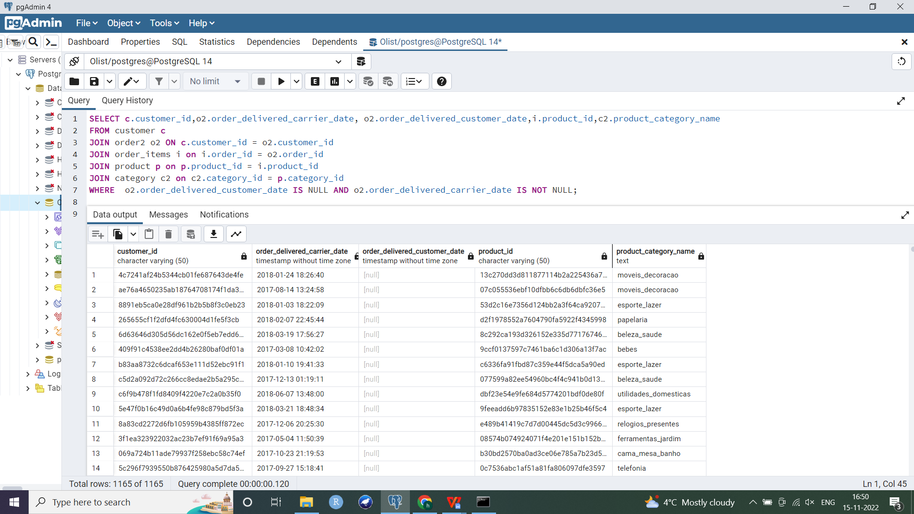

1. Retrieving records for most recent orders placed by customers. I am retrieving the customer id (since customer name is not part of my dataset), timestamp for when the order was placed, product id (since my dataset does not have product name), product details such as height and weight of product ordered and which category the product belongs to. I am joining Customer, Orders, Product, Category and Order_items to get these attributes. Row number window function is used for orders placed by each customer and it is arranged based on when the order was approved. The topmost record for each customer (with row number 1) is then selected using a subquery.

I made use of subqueries and Window functions in this case.

SELECT * FROM(

SELECT c.customer_id,o2.order_purchase_timestamp, p.product_id,p.height,p.weight,c2.product_category_name,

ROW_NUMBER() OVER (PARTITION BY c.customer_id

ORDER BY o2.order_purchase_timestamp desc) AS ROW1

FROM customer c

JOIN order2 o2 ON o2.customer_id = c.customer_id

JOIN order_items i on i.order_id = o2.order_id

JOIN product p on p.product_id = i.product_id

JOIN category c2 on c2.category_id = p.category_id) A

WHERE ROW1=1

ORDER BY c2.customer_id;

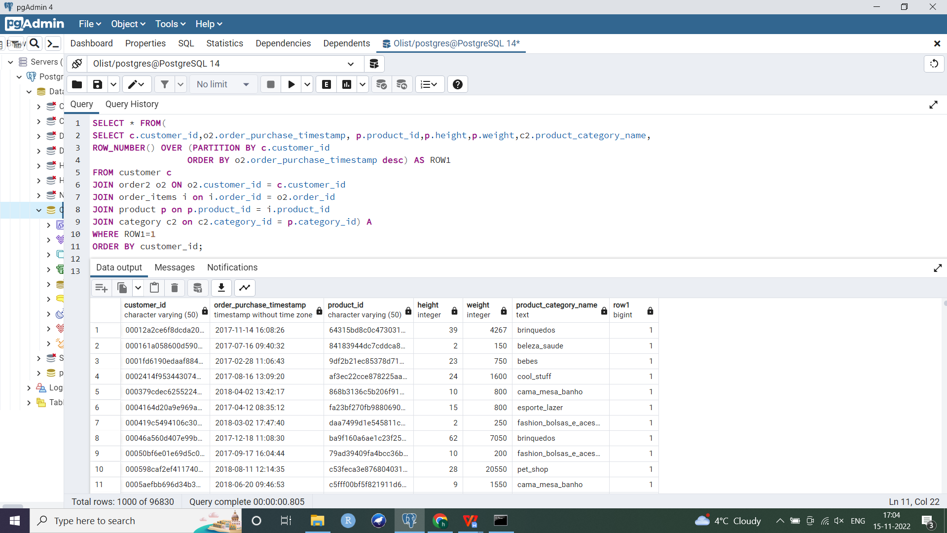

1. How many times have products of each category been bought, i.e. number of orders per product category. I joined Orders, Order_items, Products and Category. I grouped the records based on product category and counted number of orders per category, which were then arranged in a descending order using order by.

I reviewed aggregate functions for this query.

SELECT c2.product_category_name,COUNT(o.order_id) AS number_of_orders

FROM order2 o

JOIN order_items i on i.order_id = o.order_id

JOIN product p on p.product_id = i.product_id

JOIN category c2 on c2.category_id = p.category_id

GROUP BY c2.product_category_name

ORDER BY number_of_orders desc;

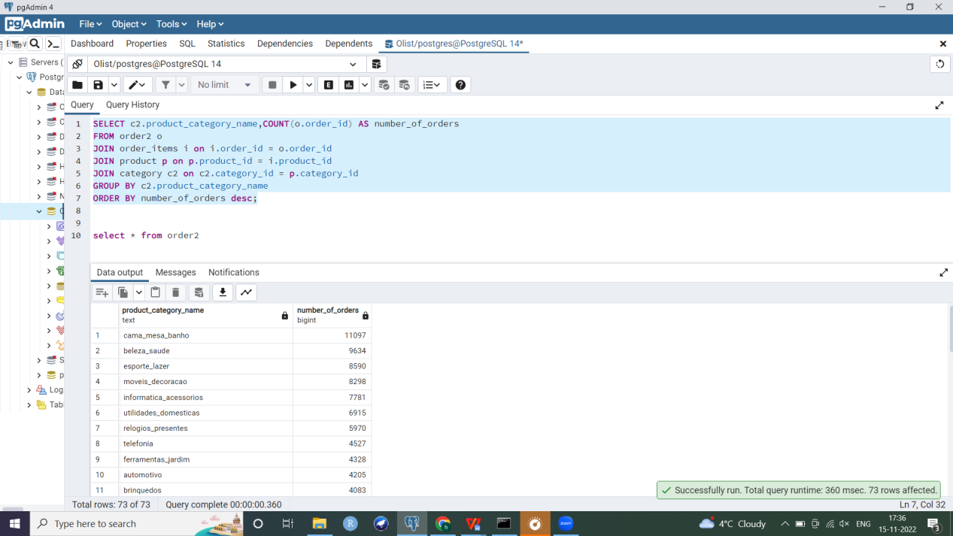

1. Returning the average delay in delivery per product, i.e. the average difference between estimated delivery day and the actual day when order reached the customer. I am again joining Orders, Order_items, Product, Product_Category and Order_reviews. I am retrieving the id of the product (since product name is not part of my dataset), the category of the product, average delay in delivery and the review rating/score for the product. I used date_part() function to extract the required part of my timetsamps (i.e. day). I also filtered records using where condition for only those orders which had already been delivered to the customer (i.e. order_delivered_customer_date is not null) and arranged rows in decreasing order of delays.

For this query, I reviewed aggregate and date functions.

SELECT p.product_id,r.review_score,c2.product_category_name,AVG(DATE_PART('day', o2.order_delivered_customer_date - o2.order_estimated_delivery_date)) AS avg_number_of_days

FROM order2 o2

JOIN order_items i ON i.order_id = o2.order_id

JOIN product p on i.product_id = p.product_id

JOIN category c2 on c2.category_id = p.category_id

JOIN order_reviews r on r.order_id=o2.order_id

WHERE o2.order_delivered_customer_date IS NOT NULL

GROUP BY p.product_id,r.review_score,c2.category_id

ORDER BY avg_number_of_days desc;

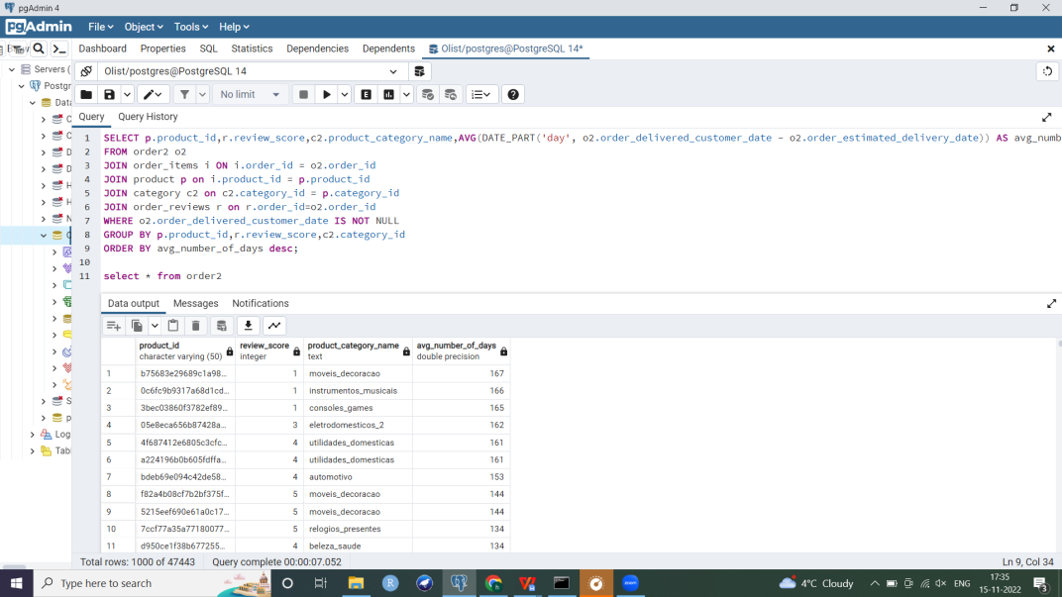

**Converting to Constellation dimensional schema** (mutliple fact and dimension tables)

I created the dimensional schema **from normalized design** since some entities from my normalized schema such as product category were an important aspect of my dimensional schema and were relevant to answering business questions.

Note: I have added screenshots of dimension tables in a later section on maintaining SCDs.

Creating the dimension tables

They do not have foreign keys constraints.

--Creating a **Customer dimension**

CREATE TABLE customer_dim AS

SELECT * FROM customer;

--Adding PK constraint

ALTER TABLE customer_dim

ADD PRIMARY KEY (customer_id);

--Dimension tables do not have foreign keys

--Creating a **Seller dimension**

CREATE TABLE seller_dim AS

SELECT * FROM sellers;

ALTER TABLE seller_dim

ADD PRIMARY KEY (seller_id);

--**Product dimension**

CREATE TABLE product_dim AS

SELECT product_id,product_photos_qty,height,weight,length,width FROM product;

ALTER TABLE product_dim

ADD PRIMARY KEY (product_id);

--**Product category dimension**

CREATE TABLE category_dim AS

SELECT * from category;

ALTER TABLE category_dim

ADD PRIMARY KEY (category_id);

**--Creating time dimensions**

--**Purchase time dimension** stores when the product was purchased/ when order was placed

--Creating the table

CREATE TABLE Purchased_time_dim

(

Purchase_id varchar(50),

purchase_year double precision,

purchase_quarter numeric,

purchase_month double precision,

purchase_day double precision,

purchase_clocktime time

);

--Creating sequence for purchase id

CREATE SEQUENCE purchase_id_seq AS INT INCREMENT BY 1 START WITH 1;

--Separating parts of purchase timestamp from the Orders table into new time dimension

--I used date_part() to extract year, month and day; extract() to get the quarter and date_trunc() for clocktime attribute of the purchased time dimension

INSERT INTO purchased_time_dim (Purchase_id,purchase_year,purchase_quarter,purchase_month,purchase_day,purchase_clocktime)

SELECT nextval('purchase_id_seq'), date_part('year',order_purchase_timestamp),extract (quarter from order_purchase_timestamp),date_part('month',order_purchase_timestamp),

date_part('day',order_purchase_timestamp),date_trunc('minute',order_purchase_timestamp) as purchase_clocktime

FROM Order2;

--adding PK to purchase time table

ALTER TABLE purchased_time_dim

ADD PRIMARY KEY (purchase_id);

--Retrieving data to check the newly created time dimension

Select * from purchased_time_dim;

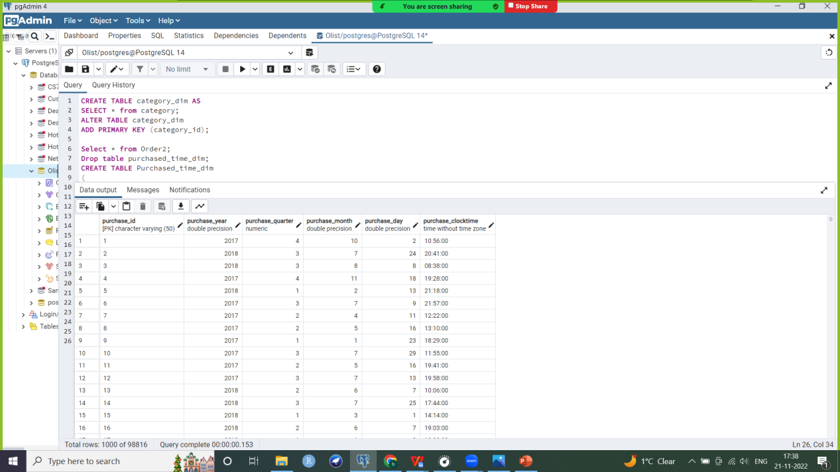

--**Date dimension**

--Creating Date dimension which represents when each review was created. It contains the year, quarter and month of review creation date. It is at a lower level of granularity as compared to the previous purchased time dimension.

--Creating table and setting datatypes

CREATE TABLE Date

(

Date_id varchar(50),

date_year double precision,

date_quarter numeric,

date_month double precision,

date_day double precision

);

--Creating sequence for date_id PK

CREATE SEQUENCE date_id_seq AS INT INCREMENT BY 1 START WITH 1;

--Segregating parts of review creation date from Order_Reviews table and inserting into dimension table using date_part() and extract() commands

INSERT INTO date (date_id,date_year,date_quarter,date_month,date_day)

SELECT nextval('date_id_seq'), date_part('year',review_creation_date),extract (quarter from review_creation_date),date_part('month',review_creation_date),

date_part('day',review_creation_date)

FROM Order_Reviews;

--add PK to date dimension table

ALTER TABLE Date

ADD PRIMARY KEY (date_id);

Select * from Date;

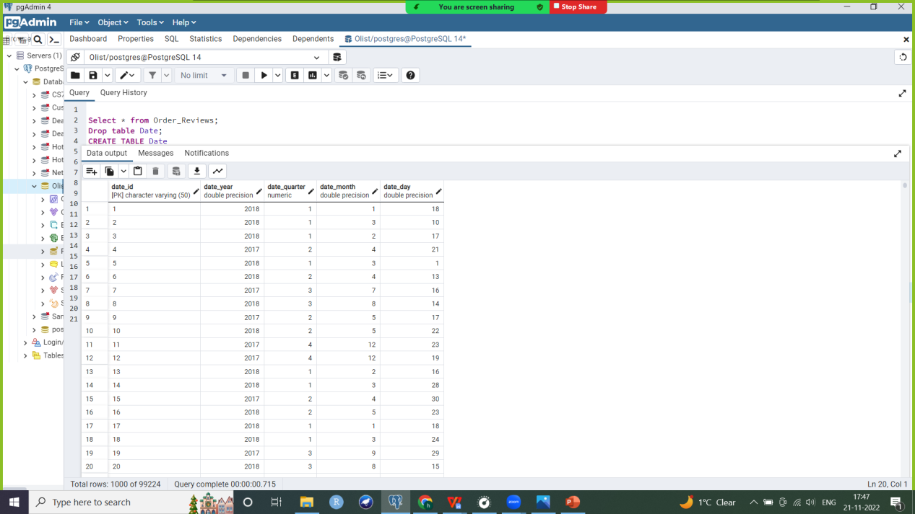

**--Month dimension table**

--It represents when the product was purchased/ when order was placed similar to the purchased_time dimension but at a lower level of granularity

CREATE TABLE Month

(

Month_id varchar(50),

year double precision,

quarter numeric,

month double precision

);

--Creating sequence for month id

CREATE SEQUENCE month_seq_id AS INT INCREMENT BY 1 START WITH 1;

INSERT INTO Month (month_id,year,quarter,month)

SELECT nextval('month_seq_id'), date_part('year',order_purchase_timestamp),extract (quarter from order_purchase_timestamp),date_part('month',order_purchase_timestamp)

FROM Order2;

--adding PK constraint

ALTER TABLE Month

ADD PRIMARY KEY (month_id);

Select * from Month;

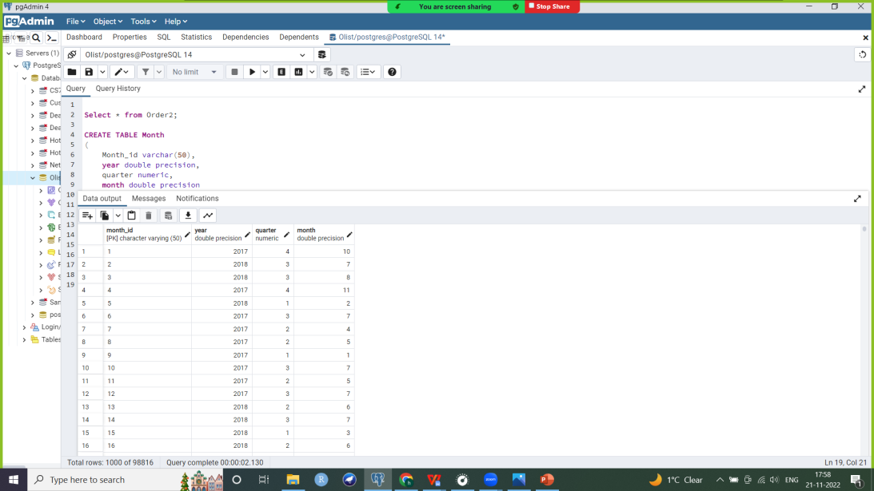

Creating fact tables

1. Review table

This fact table contains 3 foreign keys referencing the customer, product and Date dimensions. Fact tables do not reference other fact tables. Here Date dimension stored year, quarter and month of review creation. This forms the composite PK of this snapshot fact table. It also contains a review score measure.

--Adding date id to order reviews table (to use as FK) for joining with date dimension

ALTER TABLE Order_reviews

ADD COLUMN date_id varchar(50);

CREATE SEQUENCE date_id_seq3 AS INT INCREMENT BY 1 START WITH 1 OWNED BY order_reviews.date_id;

ALTER TABLE Order_reviews ALTER COLUMN date_id SET DEFAULT nextval('date_id_seq3');

UPDATE Order_reviews SET date_id = nextval('date_id_seq3');

--make date_id in order reviews table FK referencing Date dimension

ALTER TABLE order_reviews

ADD CONSTRAINT date_id FOREIGN KEY (date_id) REFERENCES Date(date_id);

--Joining dimension tables and inserting into new Review fact table

CREATE TABLE Review as

Select c.customer_id, o.order_id, p.product_id, r.review_score, d.date_id

from Customer c

join Order2 o on c.customer_id = o.customer_id

join Order_items i on i.order_id = o.order_id

join Product p on p.product_id = i.product_id

join Order_reviews r on r.order_id = i.order_id

join Date d on d.date_id=r.date_id;

--deleting duplicate records from Review fact table

DELETE FROM Review

WHERE (customer_id,order_id,product_id,date_id) IN

(SELECT customer_id,order_id,product_id,date_id

FROM

(SELECT customer_id,order_id,product_id,date_id,

ROW_NUMBER() OVER( PARTITION BY customer_id,order_id,product_id,date_id

ORDER BY customer_id,order_id,product_id,date_id) AS row_num

FROM Review) t

WHERE t.row_num > 1 );

--deleting order_id column

alter table review

drop column order_id;

--adding PK constraint to review dimension table

ALTER TABLE Review

ADD PRIMARY KEY (customer_id,product_id,date_id);--composite PK

--adding FK constraints to attributes of review fact table

ALTER TABLE Review

ADD CONSTRAINT customer_dim_fk FOREIGN KEY (customer_id) REFERENCES Customer(customer_id);

ALTER TABLE Review

ADD CONSTRAINT product_dim_fk FOREIGN KEY (product_id) REFERENCES Product(product_id);

ALTER TABLE Review

ADD CONSTRAINT date_dim_fk FOREIGN KEY (date_id) REFERENCES Date(date_id);

Select * from Review;

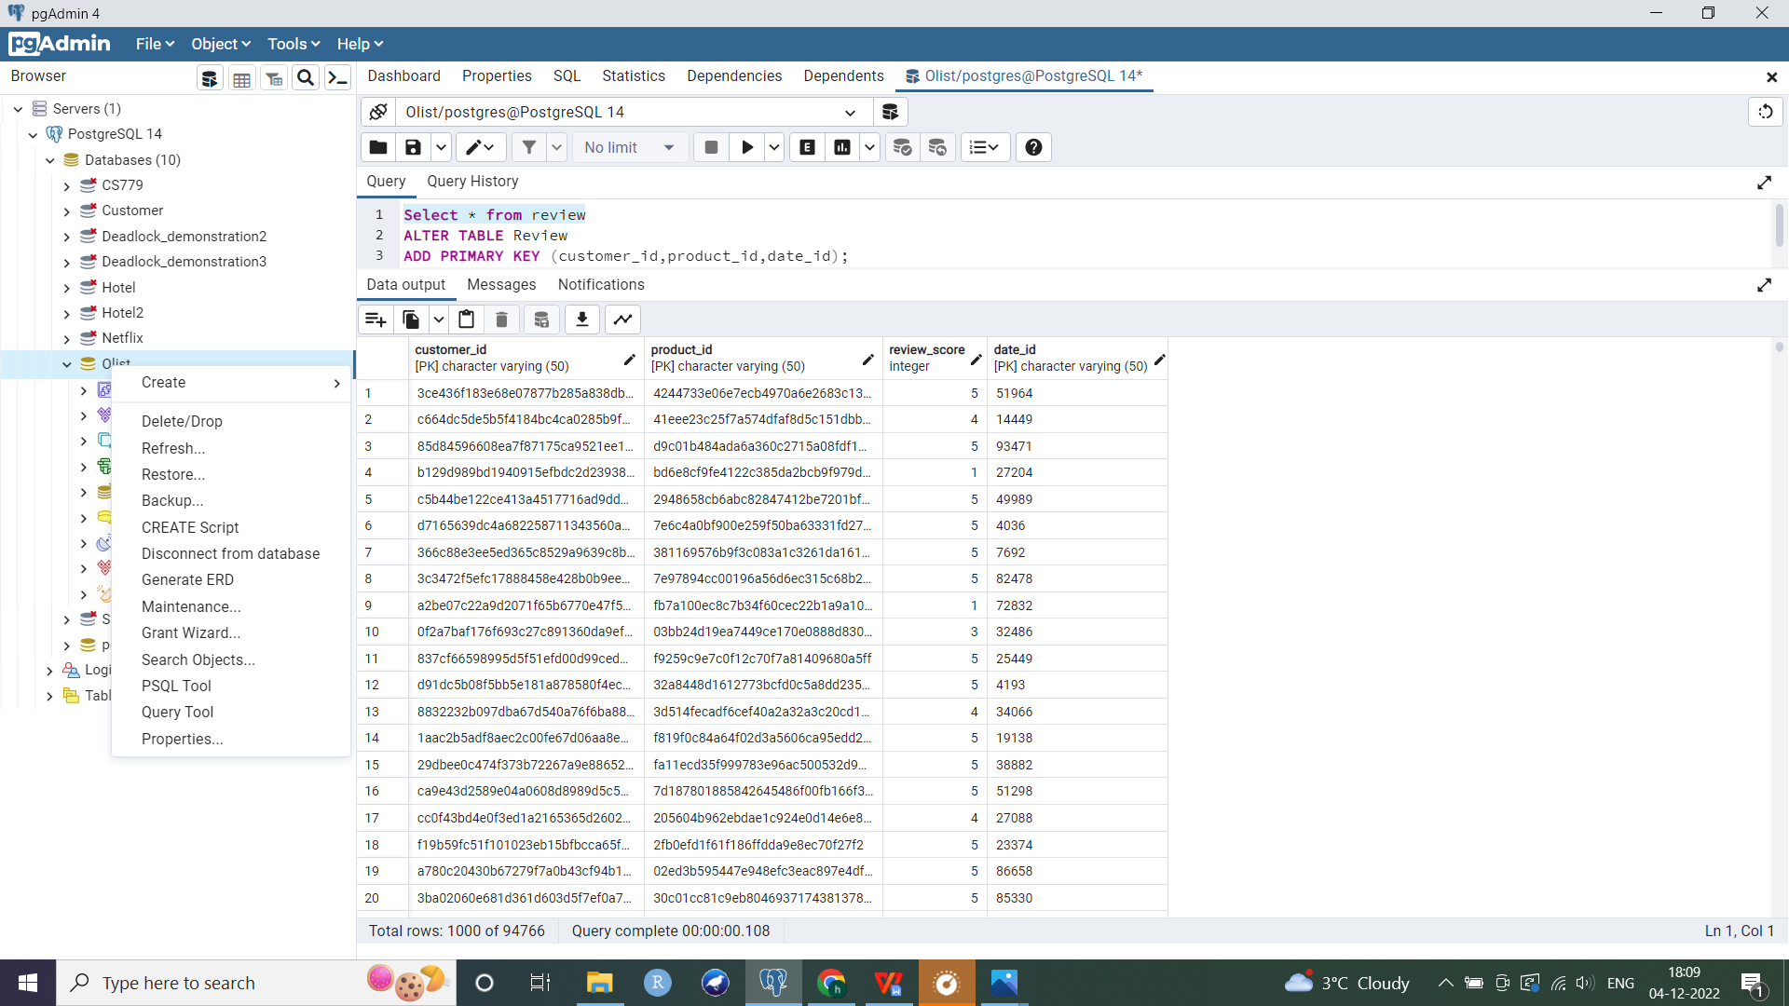

1. Product_orders fact table

This is another snapshot fact table which references the product, customer and purchase time dimensions. It also contains 3 measures: number of purchases of a particular product by a customer at a certain instant using group by, average cost per product in a purchase and total price per purchase by a customer at a certain time.

--Adding time id to Orders table as a FK to reference time dimension

ALTER TABLE Order2

ADD COLUMN purchase_time_id varchar(50); --adding column

--Inserting values in time id column of Orders table using sequence

CREATE SEQUENCE time_id_seq2 AS INT INCREMENT BY 1 START WITH 1 OWNED BY order2.purchase_time_id;

ALTER TABLE Order2 ALTER COLUMN purchase_time_id SET DEFAULT nextval('time_id_seq2');

UPDATE Order2 SET purchase_time_id = nextval('time_id_seq2');

--Adding FK constraint on time id column of orders table to reference purchased time dimension

ALTER TABLE Order2

ADD CONSTRAINT purchase_time_id FOREIGN KEY (purchase_time_id) REFERENCES Purchased_time_dim(purchase_time_id);

--Joining dimension tables and inserting into new Product Orders fact table

Create table Product_Orders as

Select c.customer_id, o.order_id, p.product_id,i.price,pt.purchase_id

from Customer c

join Order2 o on c.customer_id = o.customer_id

join Order_items i on i.order_id = o.order_id

join Product p on p.product_id = i.product_id

join Purchased_time_dim pt on pt.purchase_id=o.purchase_time_id;

--Adding a column of count/ number of purchases of a particular product by a customer at a certain

instant using group by. Creating new table Product_Orders3 with these counts (this table has lesser

number of rows since we aggregated purchases by customer, by product, by time). I also added the

average cost per product in a purchase by a customer at a certain time. In my data, the price of the

product varies a little even if customer buys the same product on the same day multiple times, hence I am taking an average.

Create table Product_Orders3 as

Select customer_id,product_id,purchase_id,avg(price::float) as product_price, count(product_id) as product_qty --casting price attribute as float datatype

from Product_Orders

group by customer_id,purchase_id,product_id;

--Add composite PK constraint to Product_Orders3 table

ALTER TABLE Product_orders3

ADD PRIMARY KEY (customer_id,product_id,purchase_id);--composite PK

--Add FK constraints

ALTER TABLE Product_Orders3

ADD CONSTRAINT customer_dim_fk2 FOREIGN KEY (customer_id) REFERENCES Customer(customer_id);

ALTER TABLE Product_Orders3

ADD CONSTRAINT product_dim_fk2 FOREIGN KEY (product_id) REFERENCES Product(product_id);

ALTER TABLE Product_Orders3

ADD CONSTRAINT time_dim_fk FOREIGN KEY (purchase_id) REFERENCES Purchased_time_dim(purchase_id);

--Adding total price column in Product Orders fact table (by multiplying product quantity and average price per product in a purchase)

Alter table Product_Orders3

Add Column Total_Price float;

UPDATE Product_Orders3

SET Total_Price=product_price * product_qty;

Select * from Product_Orders3;

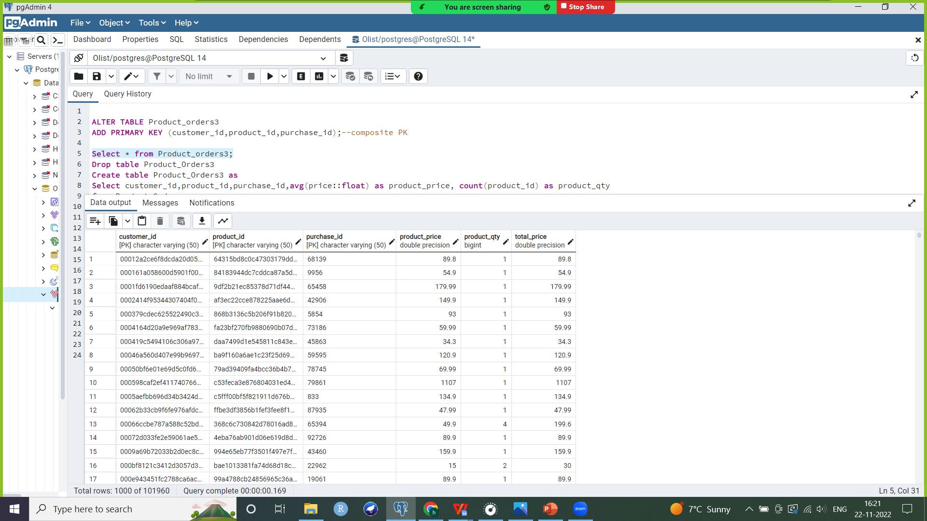

1. Sales fact table

This is a cumulative fact table. It references the seller, product category and month of purchase dimensions. It includes measures: count of sales, average price and total earnings per product category by a seller in a month.

--adding month id to Orders table as a FK to reference Month dimension

ALTER TABLE Order2

ADD COLUMN month_id varchar(50); --adding column

--Inserting values in month id column of Orders table using sequence

CREATE SEQUENCE month_id_seq2 AS INT INCREMENT BY 1 START WITH 1 OWNED BY order2.month_id;

ALTER TABLE Order2 ALTER COLUMN month_id SET DEFAULT nextval('month_id_seq2');

UPDATE Order2 SET month_id = nextval('month_id_seq2');

Select * from Order2;

--Adding FK constraint on month id column of orders table to reference purchased Month dimension

ALTER TABLE Order2

ADD CONSTRAINT month_id FOREIGN KEY (month_id) REFERENCES Month(month_id);

--Joining dimension tables and inserting into new Sales fact table

--Computing average price per product category by a seller in a month

Create table Sales as

Select s.seller_id,c.category_id, m.month_id, avg(i.price::float) as avg_sales_price

from Seller_dim s

join Order_items i on i.seller_id = s.seller_id

join Order2 o on o.order_id = i.order_id

join Product p on p.product_id = i.product_id

join Category c on c.category_id=p.category_id

join Month m on m.month_id=o.month_id

group by (s.seller_id, c.category_id, m.month_id);

--Creating new table Sales2 with counts of sales per product category by seller in a month

Create table Sales2 as

Select seller_id, category_id, month_id,avg(avg_sales_price) as avg_sales_price, count(category_id) as sales_qty

from Sales

group by seller_id, category_id, month_id;

--Add composite PK constraint to Sales2 table

ALTER TABLE Sales2

ADD PRIMARY KEY (seller_id,category_id,month_id);--composite PK

--Add FK constraints

ALTER TABLE Sales2

ADD CONSTRAINT seller_dim_fk2 FOREIGN KEY (seller_id) REFERENCES Seller_dim(seller_id);

ALTER TABLE Sales2

ADD CONSTRAINT category_dim_fk2 FOREIGN KEY (category_id) REFERENCES Category(category_id);

ALTER TABLE Sales2

ADD CONSTRAINT month_dim_fk FOREIGN KEY (month_id) REFERENCES Month(month_id);

--Adding total sales price column in Sales2 fact table by multiplying number of sales and average price

per category by seller in a month

Alter table Sales2

Add Column Total_sales_price float;

UPDATE Sales2

SET Total_sales_price=avg_sales_price * sales_qty;

Select * from Sales2;

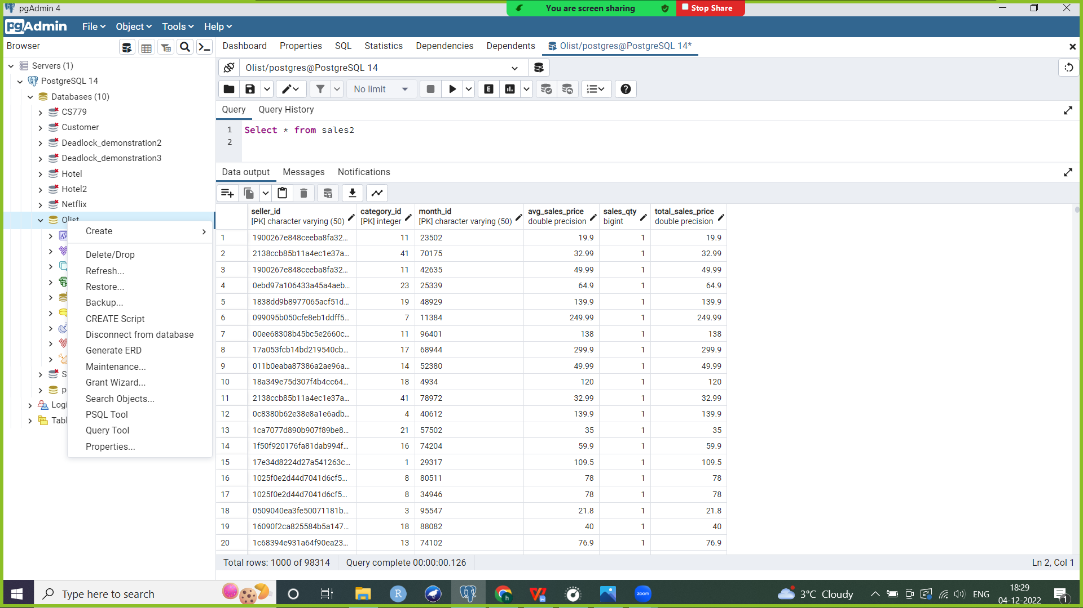

**Maintaining Slowly Changing Dimension**

**SCD 1**: The following dimensions are SCD1 since their values change infrequently and we are not particularly interested in recording old vs new values. I am inserting a record if does not exist. If a matching record does exist, then I will update or overwrite it using a stored procedure.

1. **Seller dimension**

--Creating staging table for seller dimension which will load the incremental changes that come from

the source system. Staging table will not have a PK.

--Creating a stored procedure which inserts a new record into the staging table. It then compares if a record with the same PK (seller_id) exists in the corresponding dimension table. If not, it simply inserts this record into the dimension table.

--If matching PK was found (i.e. if seller_id in our input parameters which we are inserting into staging table matches an already existing record in the dimension table), then we update values of that record in the dimension table.

Select * from seller_dim;

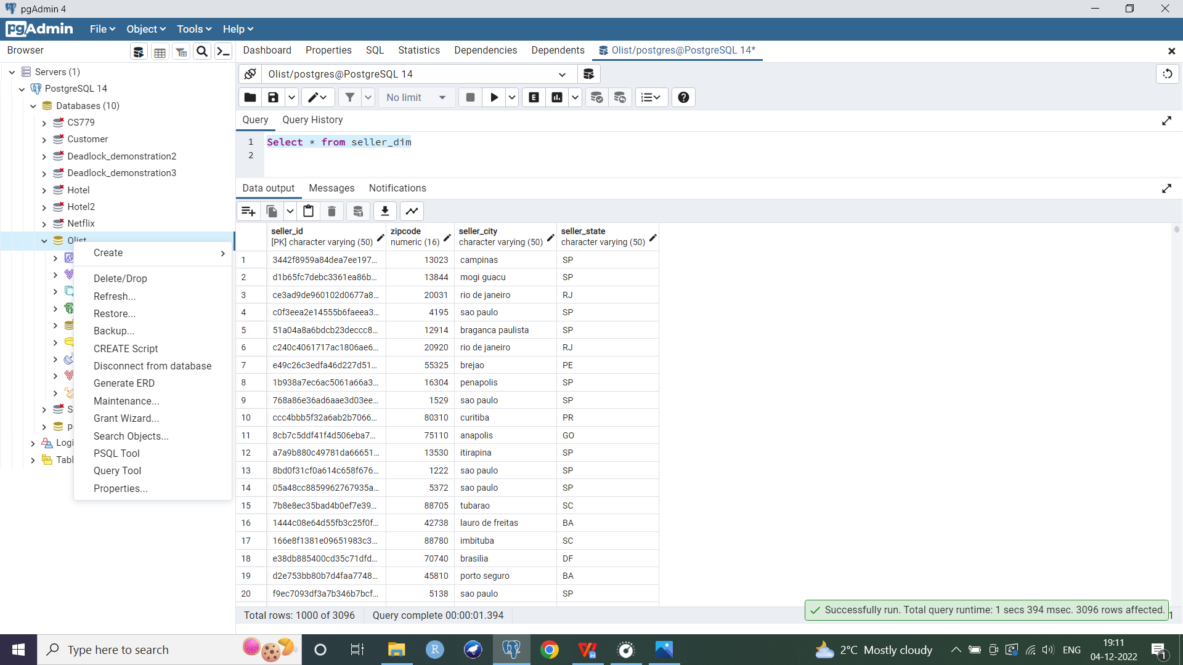

Create table Seller_staging as select * from seller_dim;

CREATE OR REPLACE FUNCTION scd1_seller(

P_sellerid VARCHAR(50),

P_zipcode NUMERIC(16),

P_city VARCHAR(50),

P_state VARCHAR(50))

Returns VOID LANGUAGE plpgsql

AS

$resuableproc$

--declaring variables

declare V_sellerid NUMERIC=0;

Begin

Insert into Seller_staging values (P_sellerid,P_zipcode,P_city,P_state); --inserting new record into staging table

--Checking if record with given PK seller_id already exists in dim table or not

If not exists (SELECT * FROM seller_dim WHERE seller_id=P_sellerid LIMIT 1) Then

--If it does not exist then insert new record in dim table also

Insert into Seller_dim values (P_sellerid,P_zipcode,P_city,P_state);

Else

--If matching record already exists, then overwrite it

Update Seller_dim Set zipcode=P_zipcode,seller_city=P_city,seller_state=P_state

Where P_sellerid=seller_id;

End if;

End;

$resuableproc$; -- closes the $$ quotation for the block

**Testing the function**

Case 1: Record does not match

DO

$$

BEGIN

EXECUTE scd1('12345',02134,'Boston','MA');

END;

$$

Select * from seller_staging where seller_id='12345';

--New record inserted into staging table

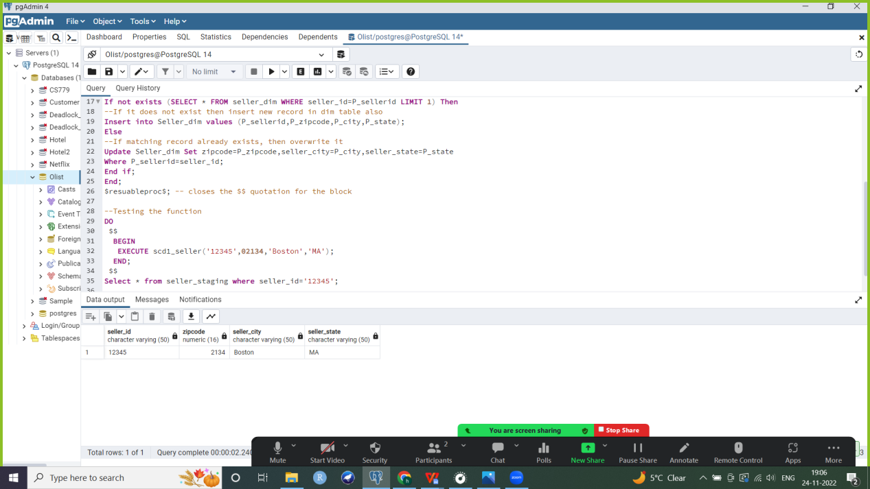

--New record inserted into dimension table

Select * from seller_dim where seller_id=’12345’;

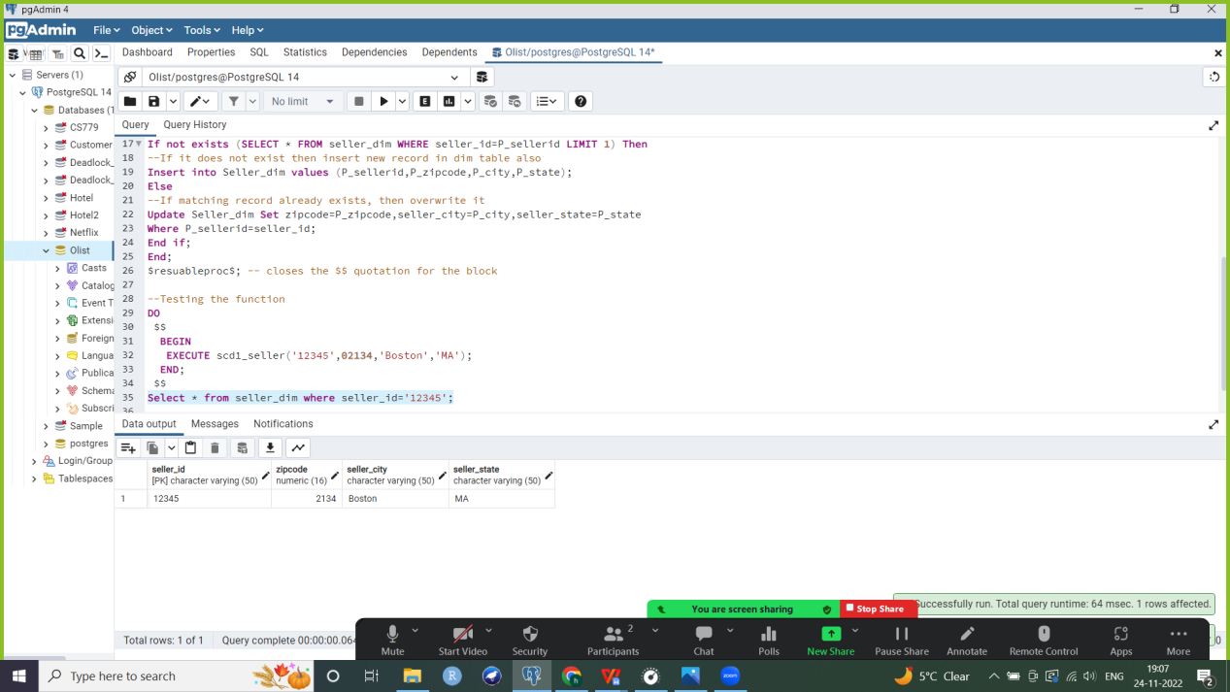

Case 2: Record does match

DO

$$

BEGIN

EXECUTE scd1_seller('12345',02134,'NY','MA');

END;

$$

Select * from seller_staging where seller_id='12345';

--New record inserted in staging table;

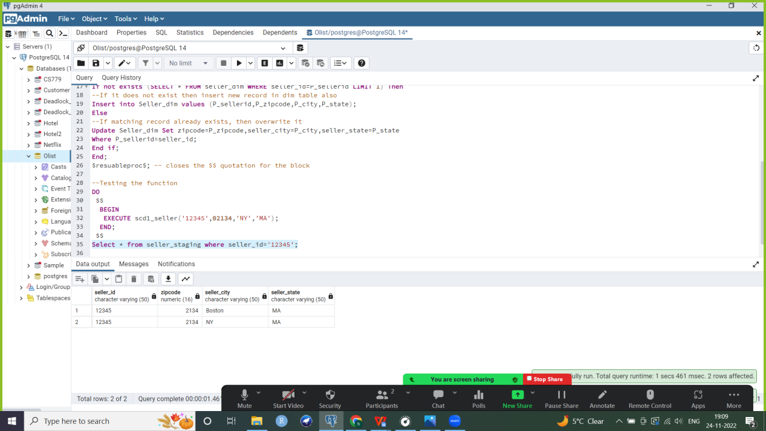

--Record gets updated in dimension table

Select * from seller_dim where seller_id='12345';

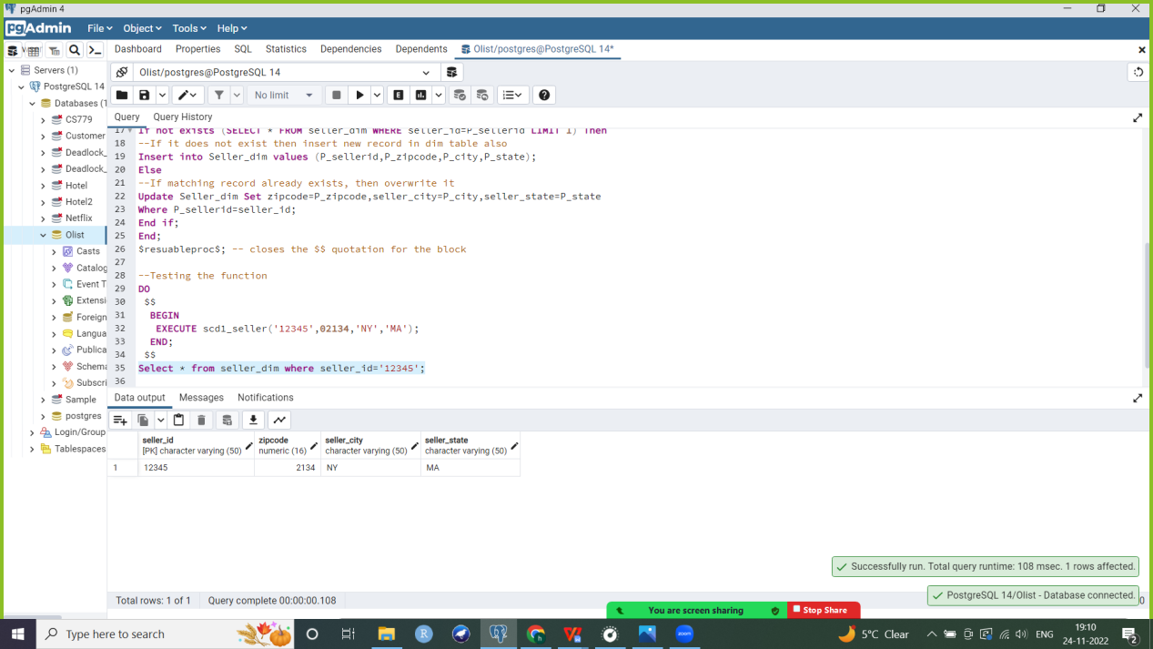

1. **Month dimension**

--This table will also be SCD 1

--Staging table without PK

Create table Month_staging as Select * from Month;

CREATE OR REPLACE FUNCTION scd1_month(

P_monthid VARCHAR(50),

P_year double precision,

P_quarter numeric,

P_month double precision)

Returns VOID LANGUAGE plpgsql

AS

$resuableproc$

--declaring variables

declare V_monthid VARCHAR;

Begin

Insert into Month_staging values (P_monthid,P_year,P_quarter,P_month); --inserting new record into staging table

--Checking if record with given PK already exists in dim table or not

If not exists (SELECT * FROM Month WHERE month_id=P_monthid LIMIT 1) Then

--If it does not exist then insert new record in dim table also

Insert into Month values (P_monthid,P_year,P_quarter,P_month);

Else

--If matching record already exists, then overwrite it

Update Month Set year=P_year,quarter=P_quarter,month=P_month

Where P_monthid=month_id;

End if;

End;

$resuableproc$; -- closes the $$ quotation for the block

**Testing the function**

DO

$$

BEGIN

EXECUTE scd1_month('12345abc',2022,3,9);

END;

$$

Case 1: Record does not exist

Select * from month_staging where month_id='12345abc';

--Record gets inserted in staging and dim tables

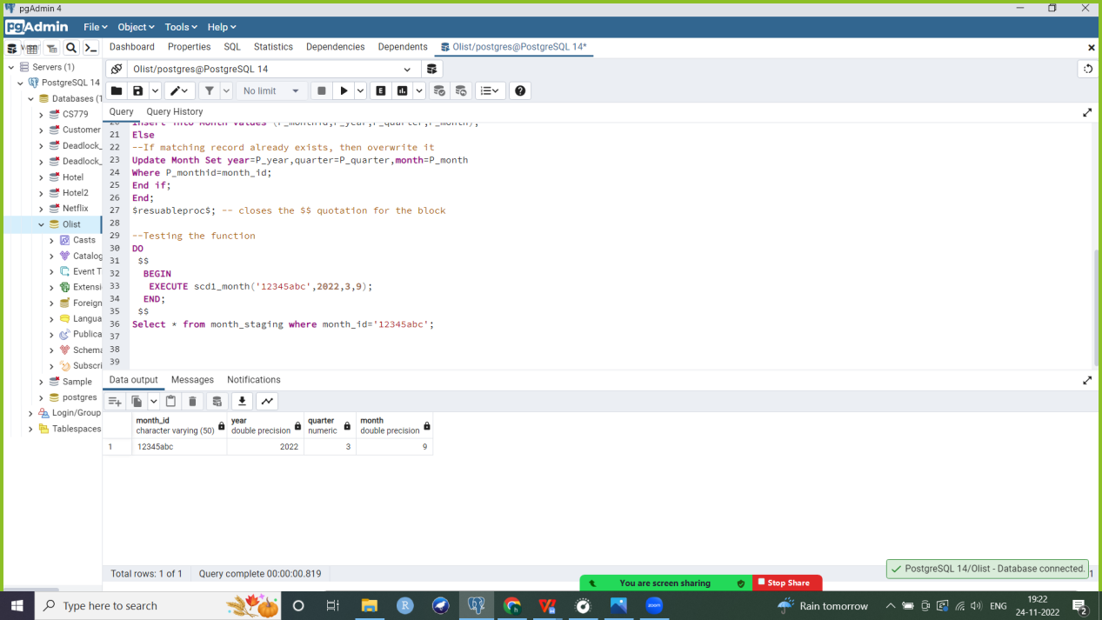

Select * from month where month_id='12345abc'; --record inserted into dimension table

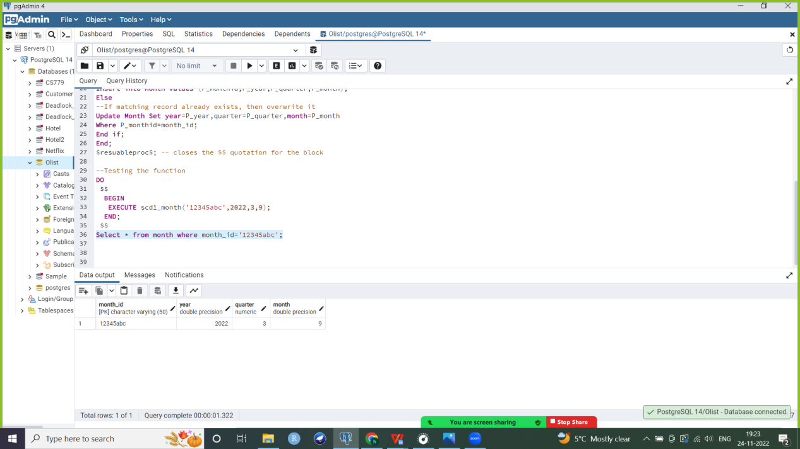

Case 2: Record matches

DO

$$

BEGIN

EXECUTE scd1_month('12345abc',2021,3,9);

END;

$$

Select * from month_staging where month_id='12345abc';

--New record gets inserted in staging table

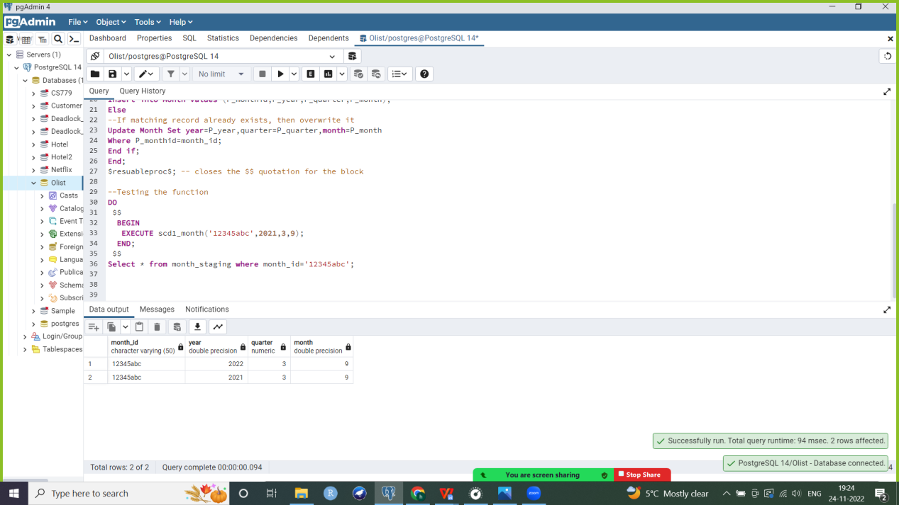

--Record gets modified in dimension table

Select * from month where month_id='12345abc';

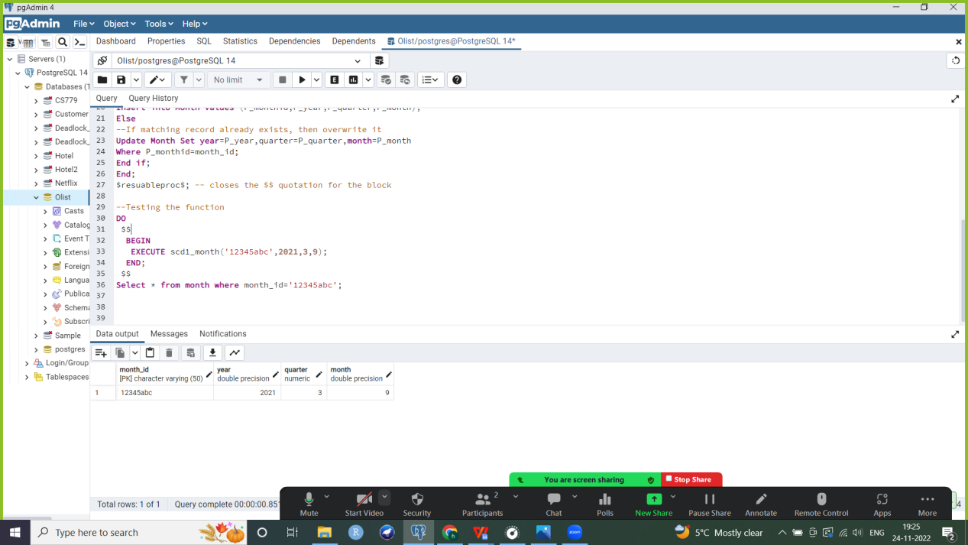

1. **Date dimension**

This dimension is also SCD 1.

--Staging table without PK

Create table Date_staging as Select * from Date;

--Stored procedure to maintain scd1

CREATE OR REPLACE FUNCTION scd1_date(

P_dateid varchar(50),

P_dateyear double precision,

P_datequarter numeric,

P_datemonth double precision,

P_dateday double precision)

Returns VOID LANGUAGE plpgsql

AS

$resuableproc$

--declaring variables

declare V_dateid VARCHAR;

Begin

Insert into Date_staging values (P_dateid,P_dateyear,P_datequarter,P_datemonth,P_dateday); --inserting new record into staging table

--Checking if record with given PK already exists in dim table or not

If not exists (SELECT * FROM Date WHERE date_id=P_dateid LIMIT 1) Then

--If it does not exist then insert new record in dim table also

Insert into Date values (P_dateid,P_dateyear,P_datequarter,P_datemonth,P_dateday);

Else

--If matching record already exists, then overwrite it

Update Date Set date_year=P_dateyear,date_quarter=P_datequarter,date_month=P_datemonth,date_day=P_dateday

Where P_dateid=date_id;

End if;

End;

$resuableproc$; -- closes the $$ quotation for the block

**Testing the function**

Case 1: Record does not match

DO

$$

BEGIN

EXECUTE scd1_date('12345abc',2021,1,1,10);

END;

$$

Select * from Date_staging where date_id='12345abc';

--Inserted in staging table

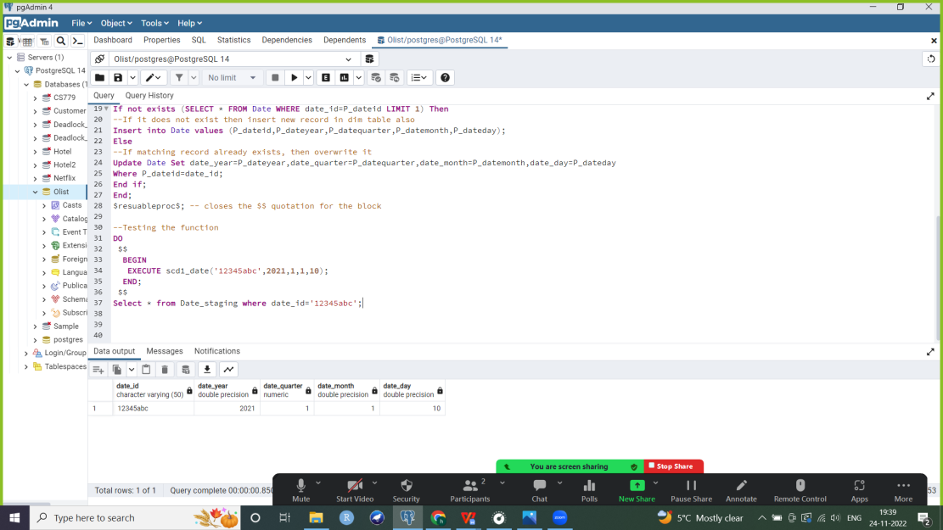

--Inserted in dimension table

Select * from Date where date_id='12345abc';

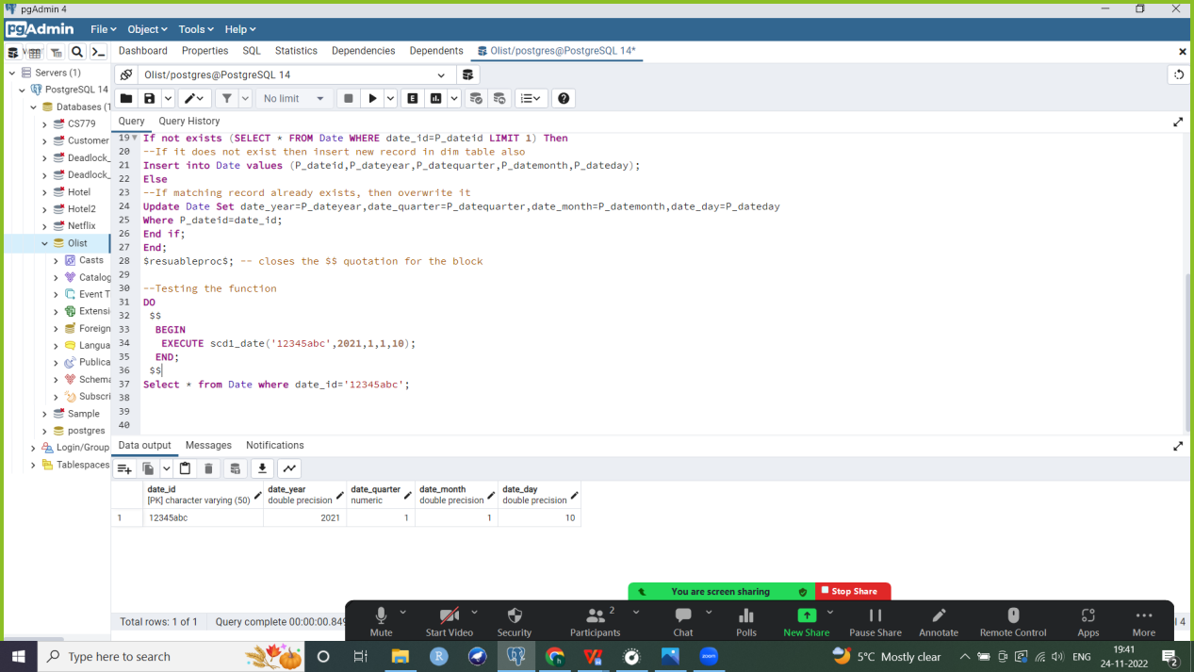

Case 2: Record already exists

DO

$$

BEGIN

EXECUTE scd1_date('12345abc',2021,1,1,15);

END;

$$

Select * from Date_staging where date_id='12345abc';

--Inserted in staging table

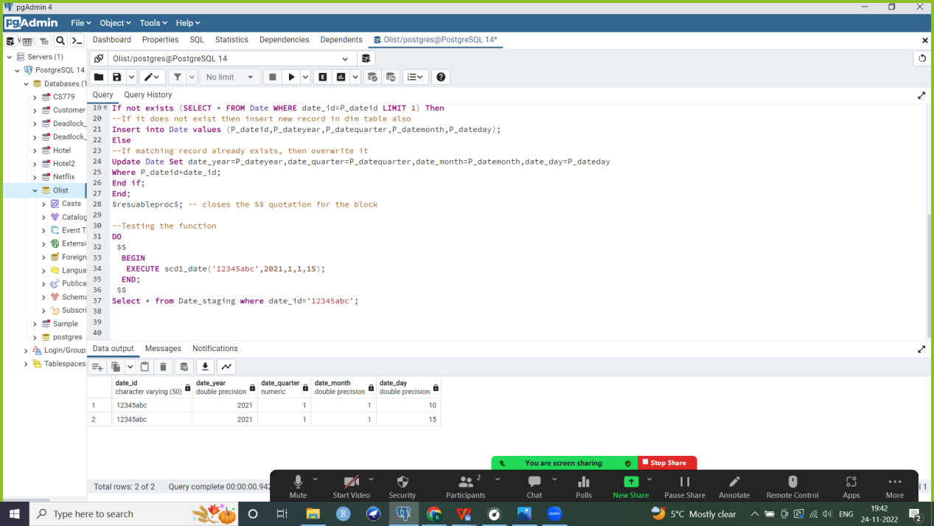

Select * from Date where date_id='12345abc';

--Record simply updated in dimension table

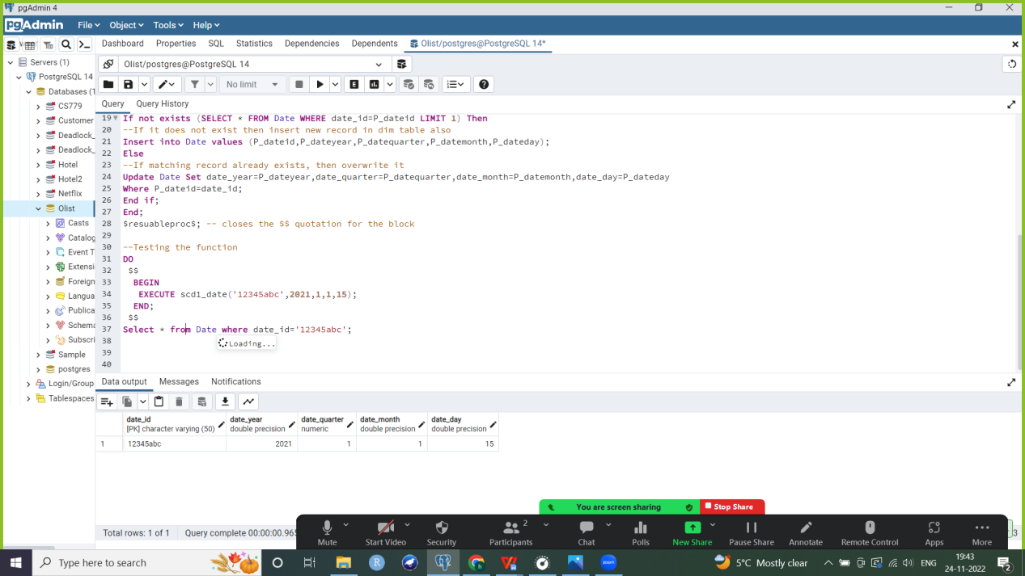

1. **Purchased_time dimension**

This dimension is SCD 1.

--Staging table without PK

Create table Purchased_time_staging as Select * from Purchased_time_dim;

--Stored procedure to maintain scd 1

CREATE OR REPLACE FUNCTION scd1_purchasedtime(

P_purchaseid varchar(50),

P_purchaseyear double precision,

P_purchasequarter numeric,

P_purchasemonth double precision,

P_purchaseday double precision,

P_purchaseclocktime time)

Returns VOID LANGUAGE plpgsql

AS

$resuableproc$

--declaring variables

declare V_purchaseid VARCHAR;

Begin

Insert into Purchased_time_staging values (P_purchaseid,P_purchaseyear,P_purchasequarter,P_purchasemonth,P_purchaseday,P_purchaseclocktime); --inserting new record into staging table

--Checking if record with given PK already exists in dimension table or not

If not exists (SELECT * FROM Purchased_time_dim WHERE purchase_id=P_purchaseid LIMIT 1) Then

--If it does not exist then insert new record in dimension table also

Insert into Purchased_time_dim values (P_purchaseid,P_purchaseyear,P_purchasequarter,P_purchasemonth,P_purchaseday,P_purchaseclocktime);

Else

--If matching record already exists, then overwrite it

Update Purchased_time_dim Set purchase_year=P_purchaseyear,purchase_quarter=P_purchasequarter,purchase_month=P_purchasemonth,purchase_day=P_purchaseday,

purchase_clocktime=P_purchaseclocktime

Where P_purchaseid=purchase_id;

End if;

End;

$resuableproc$; -- closes the $$ quotation for the block

**Testing the function**

Case 1: Record does not exist

DO

$$

BEGIN

EXECUTE scd1_purchasedtime('12345abcd',2022,1,2,10,'09:50:00');

END;

$$

Select * from Purchased_time_staging where purchase_id='12345abcd';

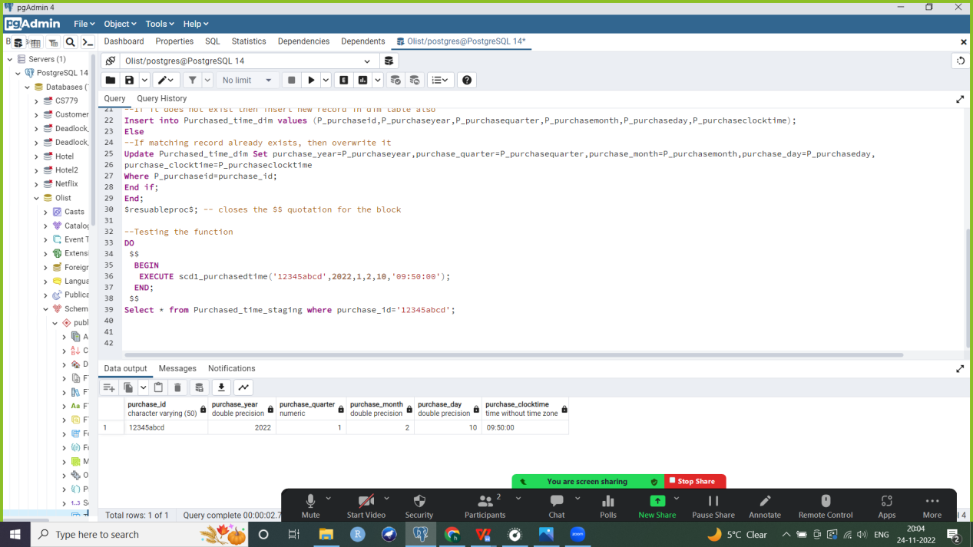

--New record inserted into dimension table

Select * from Purchased_time_dim where purchase_id='12345abcd';

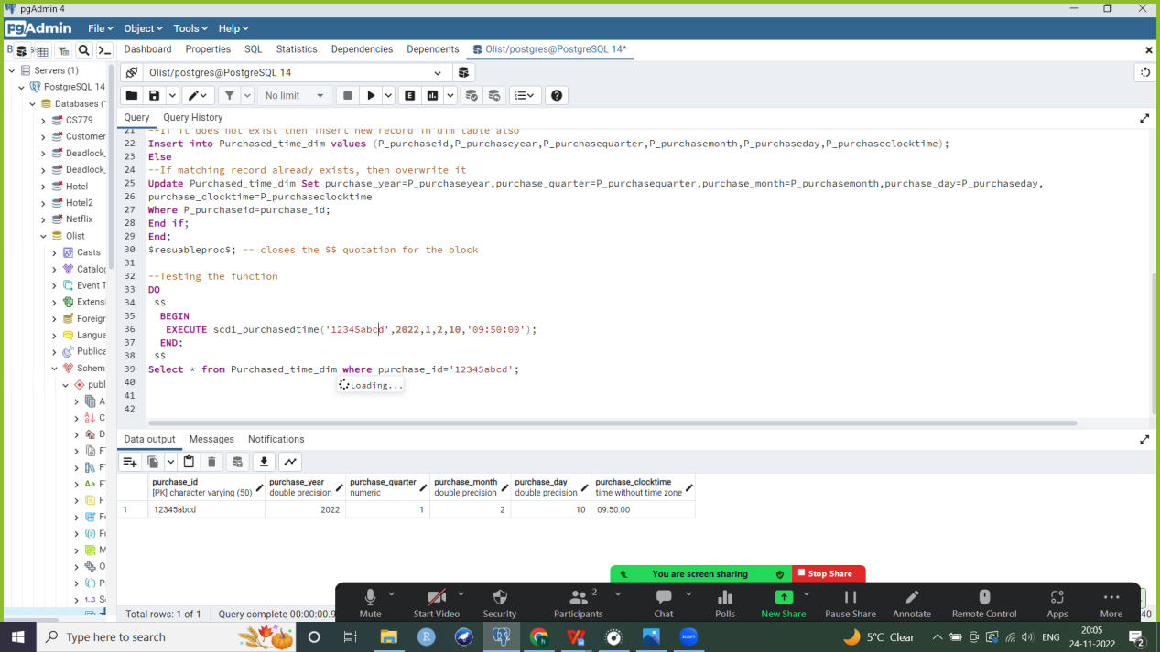

Case 2: Record does exist

DO

$$

BEGIN

EXECUTE scd1_purchasedtime('12345abcd',2017,1,2,10,'07:50:00');

END;

$$

Select * from Purchased_time_staging where purchase_id='12345abcd';

--Record inserted into staging table

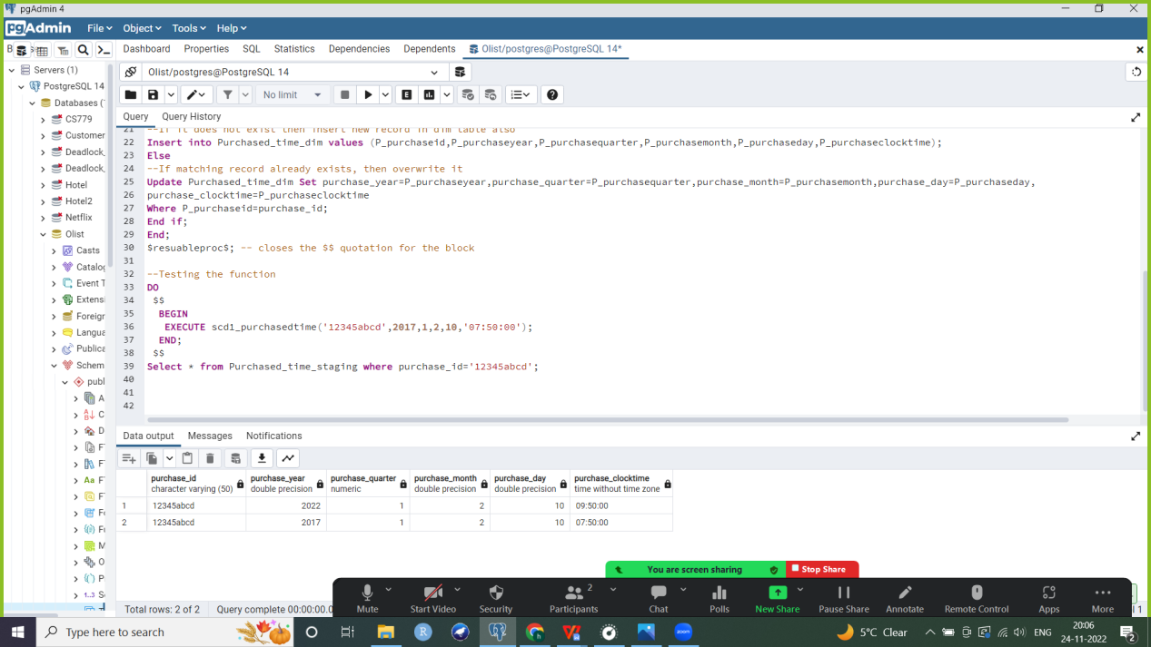

--Record updated in dimension table

Select * from Purchased_time_dim where purchased_id='12345abcd';

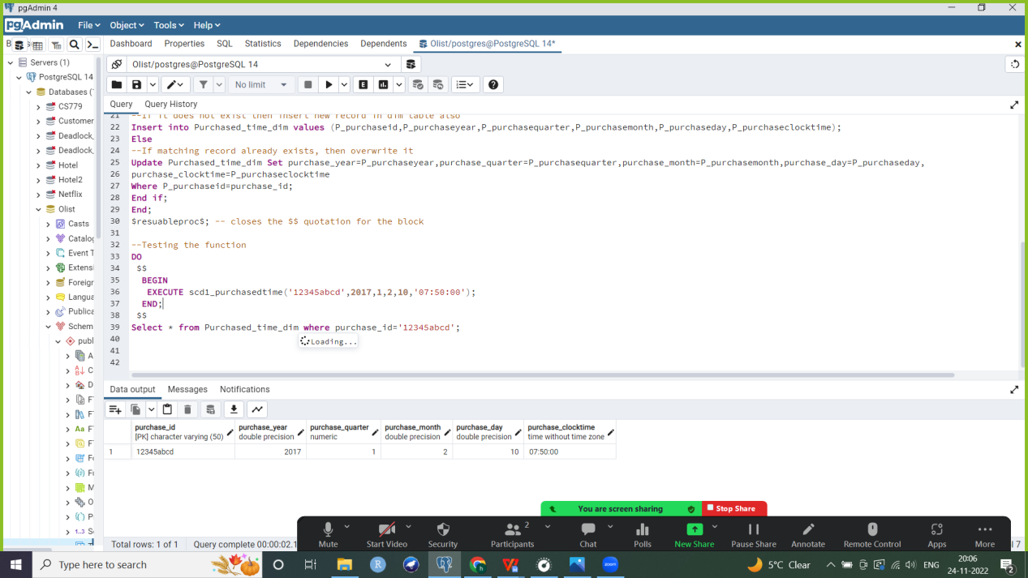

1. **Category dimension**

This dimension is also SCD 1.

Select * from Category;

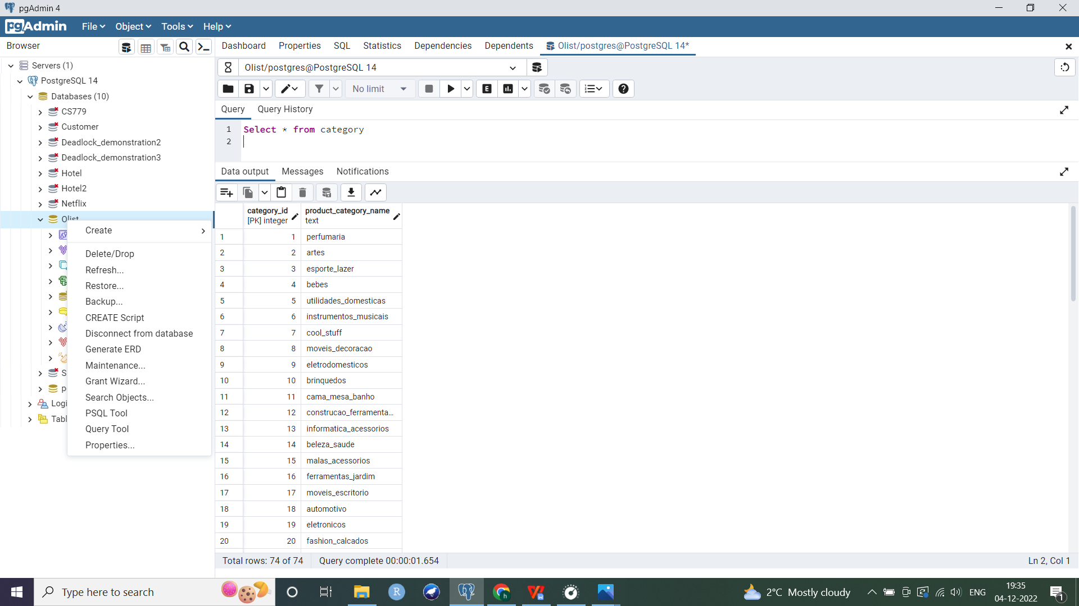

--Staging table without PK

Create table category_staging as Select * from category;

--Stored procedure to maintain scd1

CREATE OR REPLACE FUNCTION scd1_category(

P_categoryid integer,

P_productcategoryname text)

Returns VOID LANGUAGE plpgsql

AS

$resuableproc$

--declaring variables

declare V_categoryid integer;

Begin

Insert into category_staging values (P_categoryid,P_productcategoryname); --inserting new record into staging table

--Checking if record with given PK already exists in dim table or not

If not exists (SELECT * FROM category WHERE category_id=P_categoryid LIMIT 1) Then

--If it does not exist then insert new record in dim table also

Insert into category values (P_categoryid,P_productcategoryname);

Else

--If matching record already exists, then overwrite it

Update category Set product_category_name=P_productcategoryname

Where P_categoryid=category_id;

End if;

End;

$resuableproc$; -- closes the $$ quotation for the block

**Testing the function**

Case 1: Record does not exist

DO

$$

BEGIN

EXECUTE scd1_category(54321,'shoes');

END;

$$

Select * from category_staging where category_id=54321;

--inserting in staging table

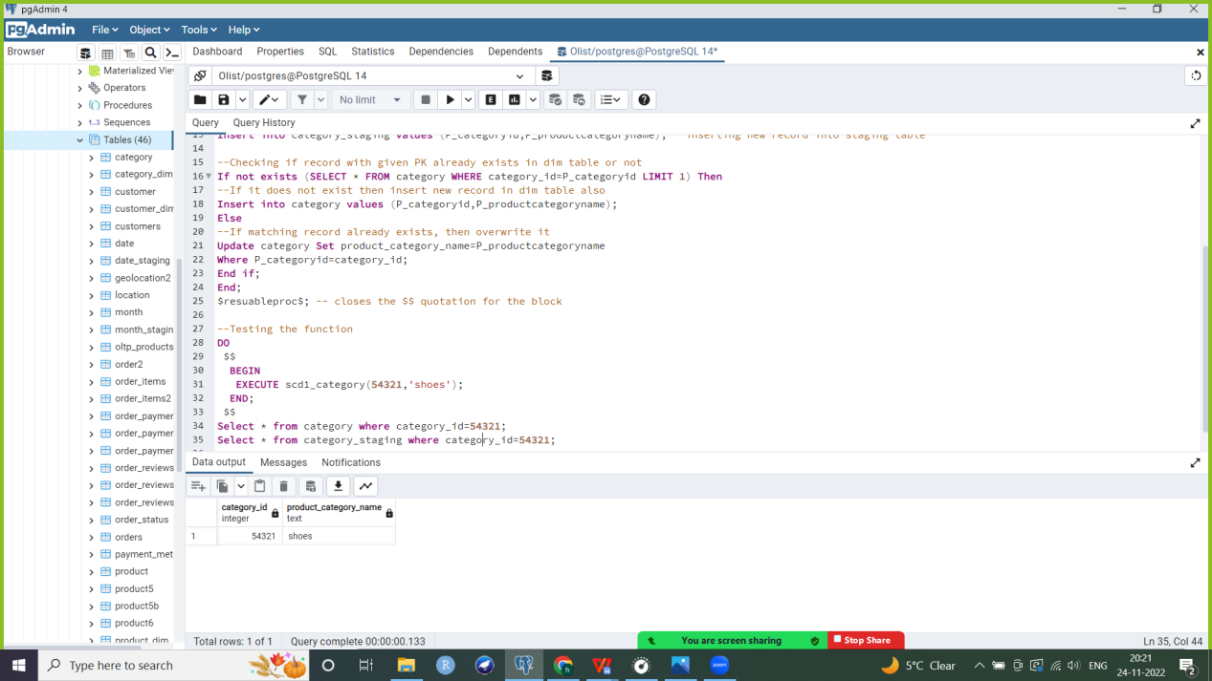

--inserting in dimension table

Select * from category where category_id=54321;

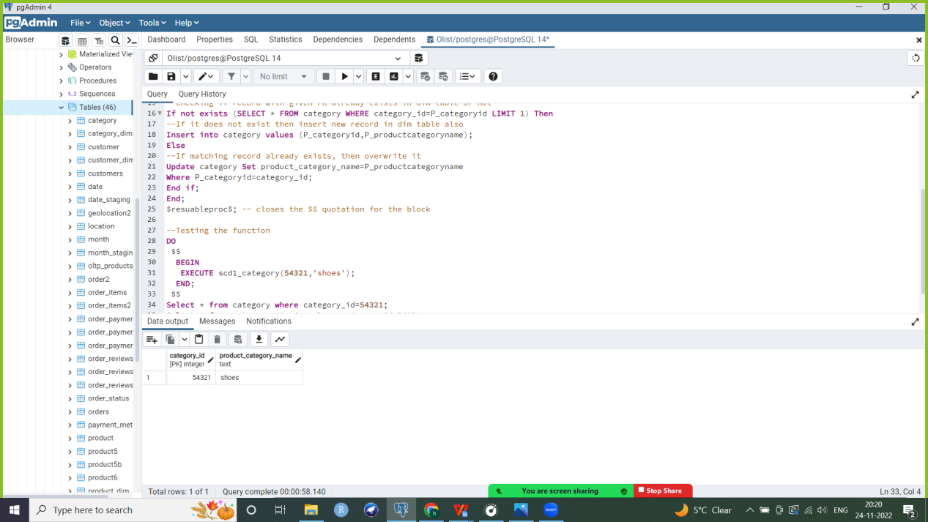

Case 2: Record exists

DO

$$

BEGIN

EXECUTE scd1_category(54321,'sneakers');

END;

$$

--inserting in staging table

Select * from category_staging where category_id=54321;

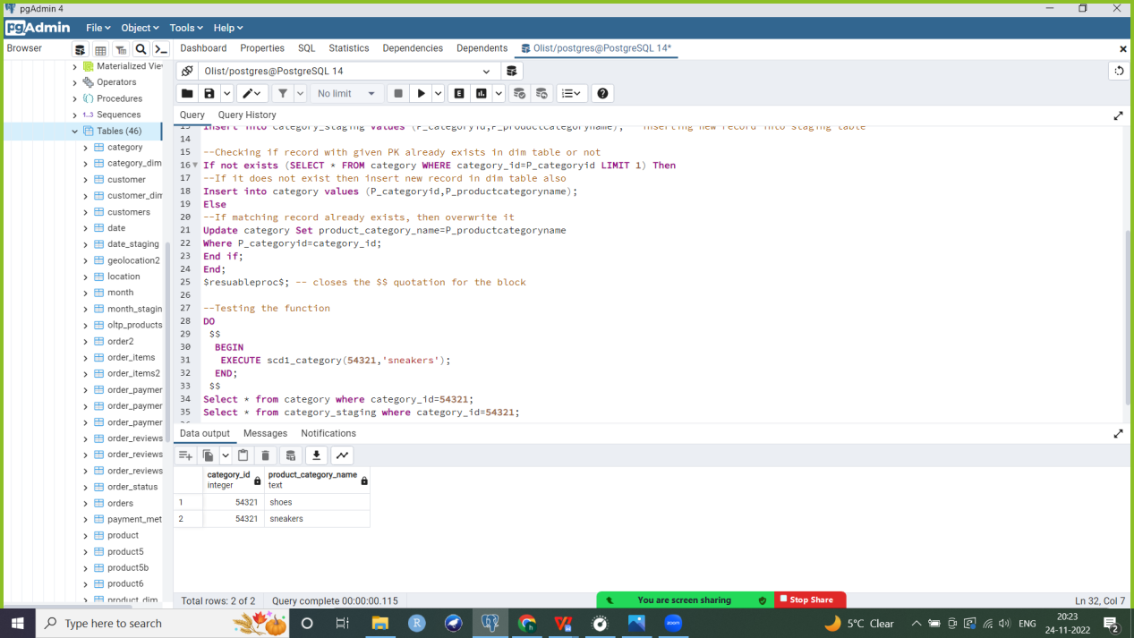

--updating in dimension table: shoes overwritten by sneakers

Select * from category where category_id=54321;

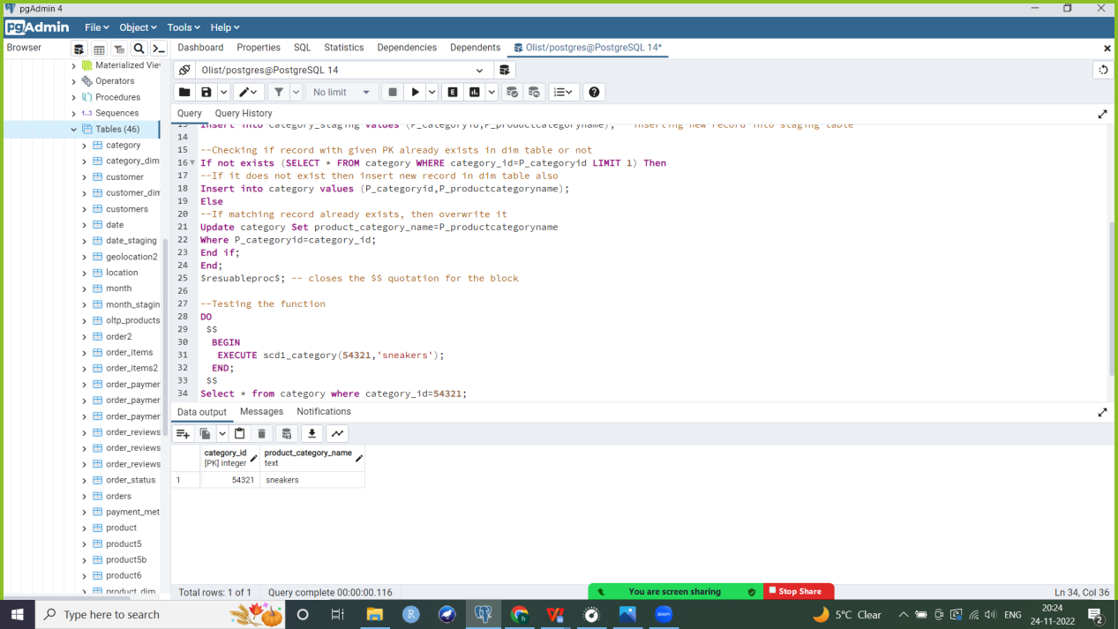

SCD 3: One of my dimension tables (Customer_dim) is scd 3 since some of its attribute values change infrequently and we are interested in recording old as well as new values.

1. **Customer**

The Customer_dim table is SCD 3. The customer’s address (including state, city and/or zipcode) changes infrequently and we want to store previous and current values of the customer’s address.

--Staging table without PK

Create table Customer_staging as select * from customer_dim;

--inserting three new attributes into dimension table to record previous values of customer’s state, city and zipcode

Alter table customer_dim add column prev_zipcode numeric(16);

Alter table customer_dim add column prev_customercity varchar(50);

Alter table customer_dim add column prev_customerstate varchar(10);

Select * from Customer_dim;

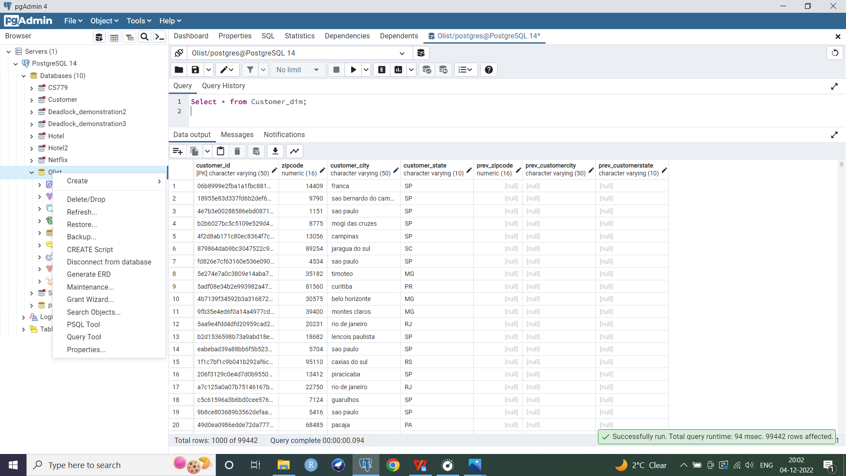

Till now the previous values are null since record with the same composite PK has not been inserted yet.

--Stored procedure to maintain scd 3

CREATE OR REPLACE FUNCTION scd3_customer(

P_Customerid VARCHAR(50),

P_Zipcode NUMERIC(16),

P_Customercity VARCHAR(50),

P_Customerstate VARCHAR(10))

Returns VOID LANGUAGE plpgsql

AS

$resuableproc$

--declaring variables

declare V_customerid integer;

Begin

Insert into customer_staging values (P_Customerid,P_Zipcode,P_Customercity,P_Customerstate); --inserting new record into staging table

--Checking if record with given PK already exists in dim table or not

If not exists (SELECT * FROM customer_dim WHERE Customer_id=P_Customerid LIMIT 1) Then

--If it does not exist then insert new record in dim table also

Insert into customer_dim(customer_id,zipcode,customer_city,customer_state,prev_zipcode,prev_customercity,prev_customerstate) values (P_Customerid,P_Zipcode,P_Customercity,P_Customerstate,null,null,null);

Else

--if customer id already exists

--check if each attribute we are tracking previous, current values for has changed or not

--checking if zipcode for given customer id has been updated

if not exists(select * from customer_dim where zipcode=p_zipcode and customer_id=p_customerid) then

--If it has been modified then update current zipcode to the value we just inserted (used as function

--parameter) and set earlier value of zipcode as previous value

update customer_dim set prev_zipcode=zipcode

where customer_id=P_customerid;

update customer_dim set zipcode=P_zipcode

where customer_id=P_customerid;

End if;

--checking the same for city attribute

if not exists(select * from customer_dim where customer_city=p_customercity and customer_id=p_customerid) then

update customer_dim set prev_customercity=customer_city

where customer_id=P_customerid;

update customer_dim set customer_city=P_customercity

where customer_id=P_customerid;

End if;

--checking the same for state attribute

if not exists(select * from customer_dim where customer_state=p_customerstate and customer_id=p_customerid) then

update customer_dim set prev_zipcode=customer_state

where customer_id=P_customerid;

update customer_dim set customerstate=P_customerstate

where customer_id=P_customerid;

End if;

End if;

End;

$resuableproc$; -- closes the $$ quotation for the block

**Testing the function**

Case 1: Matching record does not exist

DO

$$

BEGIN

EXECUTE scd3_customer('12345abcd',02134,'Boston','MA');

END;

$$

Select * from Customer_staging where customer_id=’12345abcd’;

--Record inserted into staging table

--Staging table does not have the 3 new attributes we added to the dimension table to store previous values of attributes

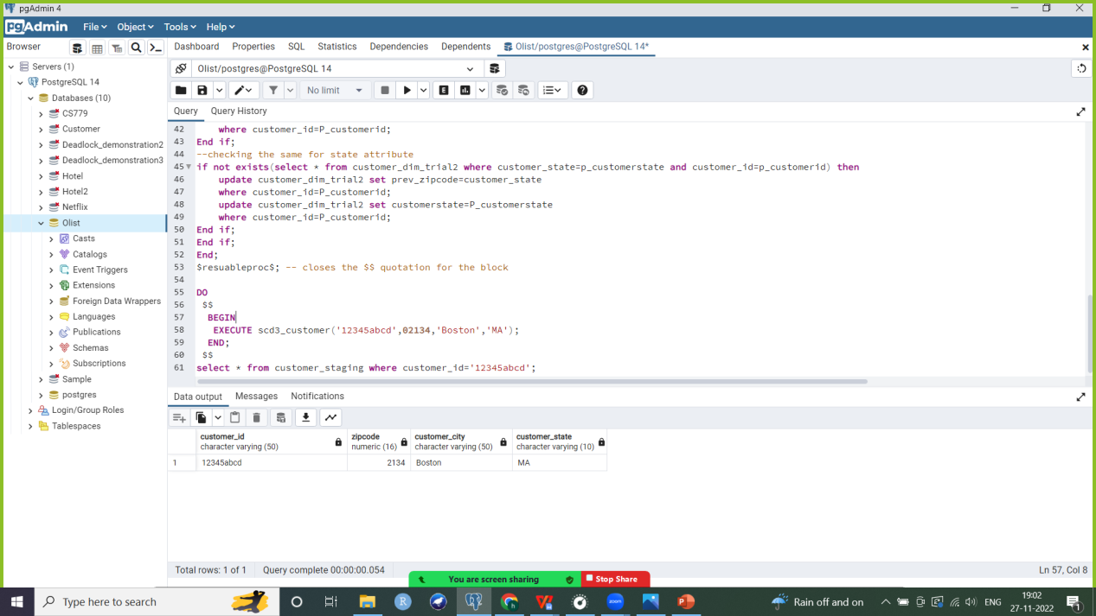

--Record inserted into dimension table

Select * from customer_dim where customer_id=’12345abcd’;

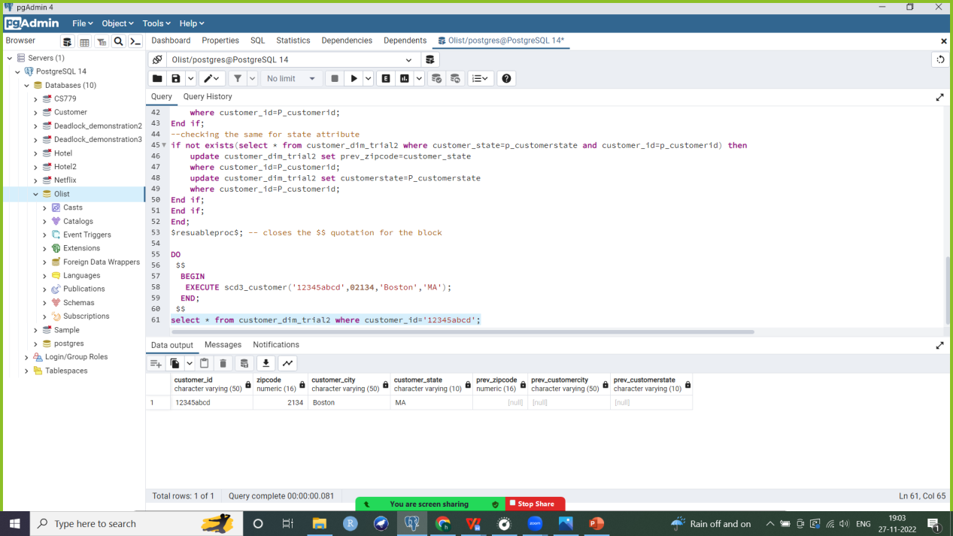

--Here previous values are null since record has been inserted for the first time and no values have been updated yet

Case 2: Record exists and some values have changed (here, zipcode and city)

DO

$$

BEGIN

EXECUTE scd3_customer('12345abcd',01156,'Allston','MA');

END;

$$

Select * from customer_staging where customer_id='12345abcd'; --record inserted in staging table

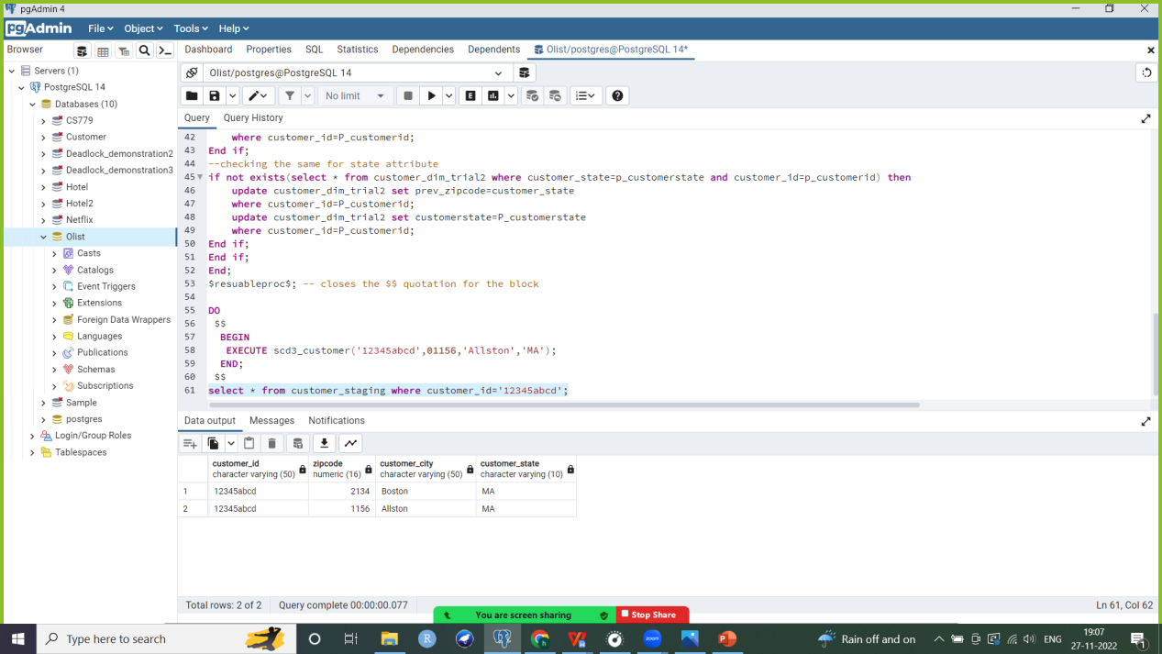

Select * from customer_dim where customer_id='12345abcd';--record updated in dimension table

--city and zipcode have previous and current values

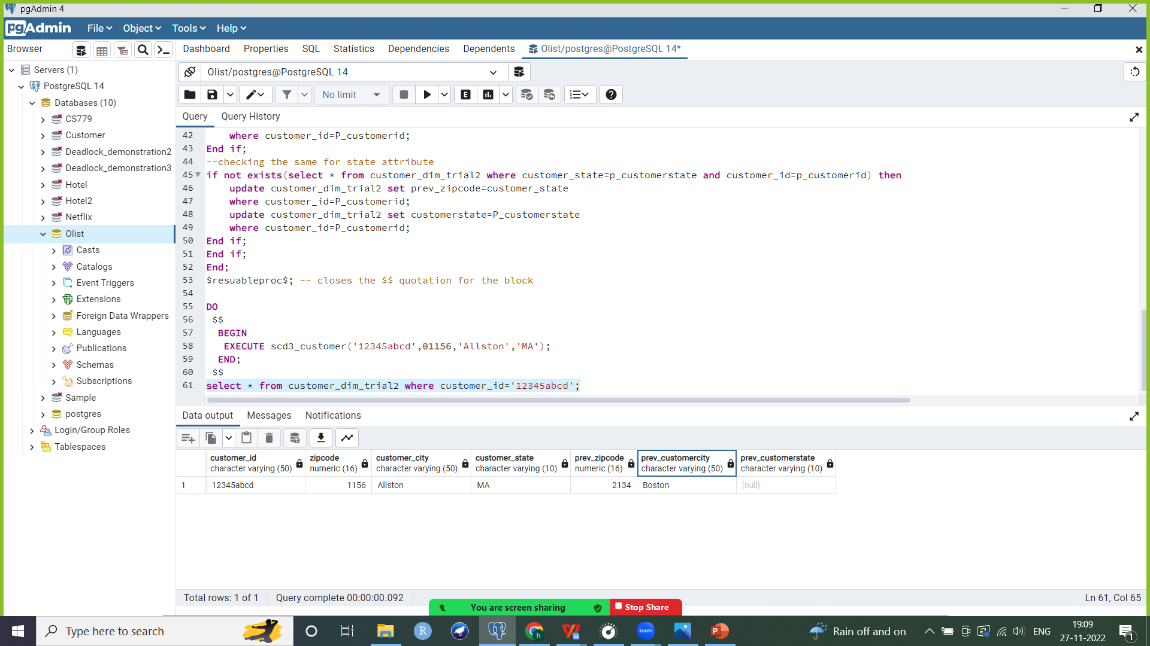

Case 3: Record exists but no updates have occurred in its attribute values

DO

$$

BEGIN

EXECUTE scd3_customer('12345abcd',01156,'Allston','MA');

END;

$$

Select * from customer_dim where customer_id='12345abcd';

--dimension table remains unchanged



Select * from customer_staging where customer_id='12345abcd'; --staging table now has 3 records associated with customer id ‘12345abcd’

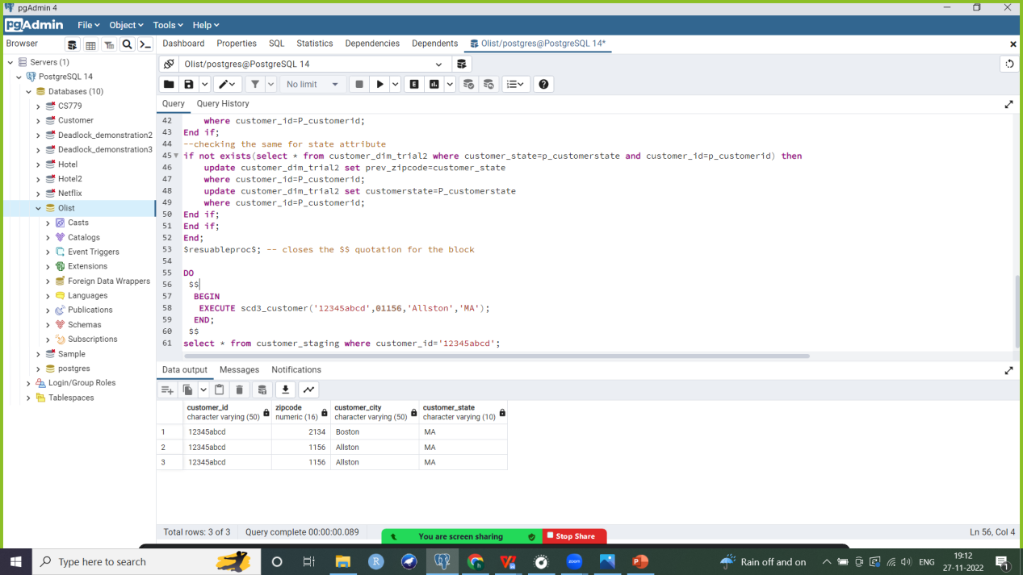

SCD 2: My Product dimension table is scd2. It has attributes with frequently changing values and we want to store the start and end dates for which each record is valid using current flag, effective timestamp and expire timestamp fields.

1. **Product_dim**

This dimension table is SCD 2. Attributes of the product such as height, weight and other dimensions frequently change. Whenever a change occurs, a new record is added to the dimension table and effective, expire timestamps and current flag values are modified accordingly.

--Staging table without PK

Create table Product_staging as select * from product_dim;

--Creating dimensional table with synthetic PK

Create table Product_dim2 as select * from product_dim;

--adding synthetic PK since product_dim is scd2 and multiple records with same id can exist

Alter table product_dim2 add column product_dim_id varchar(50);

CREATE SEQUENCE product_dim_id_seq2b AS INT INCREMENT BY 1 START WITH 1;

ALTER TABLE product_dim2 ALTER COLUMN product_dim_id SET DEFAULT nextval('product_dim_id_seq2b');

UPDATE product_dim2 SET product_dim_id = nextval('product_dim_id_seq2b');

--adding PK constraint

Alter table product_dim2 add primary key (product_dim_id);

--Adding 3 new attributes: current flag, effective and expire timestamps to maintain dimension using scd2

Alter table product_dim2 add column current_flag boolean;

Alter table product_dim2 add column effective_timestamp timestamp;

Alter table product_dim2 add column expire_timestamp timestamp;

--Updating values of previous records already in table for these 3 attributes: setting current flag as

--true, expire timestamp to a future date and effective timestamp as today’s date for all

Update product_dim2 set current_flag= 'true';

Update product_dim2 set expire_timestamp= '9999-01-01';

Update product_dim2 set effective_timestamp= '2022-11-26';

Select * from product_dim2;

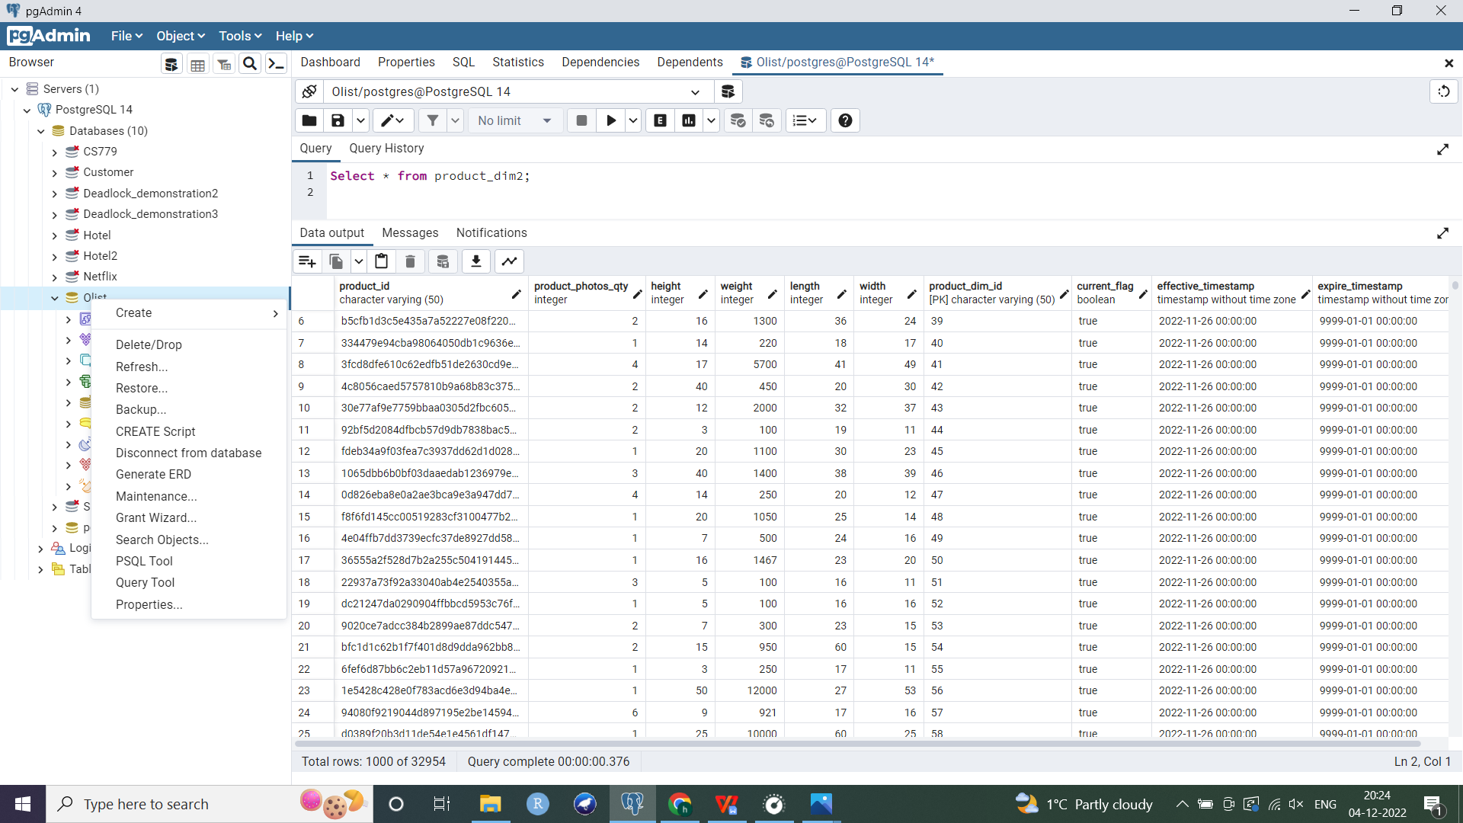

--Stored procedure to add record in product dimension table if it does not exist

--if record with same product_id already exists, then insert new record with a unique synthetic PK, same product_id, current flag as ‘true’, effective timestamp as current timestamp and expire timestamp set to a future date

--also update previous record with same product_id. Set its current flag as ‘false’ and expire timestamp to current timestamp

CREATE OR REPLACE FUNCTION scd2_product(

P_PRODUCTID VARCHAR(50),

P_PHOTOSQTY INTEGER,

P_WEIGHT INTEGER,

P_LENGTH INTEGER,

P_HEIGHT INTEGER,

P_WIDTH INTEGER)

Returns VOID LANGUAGE plpgsql

AS

$resuableproc$

Begin

Insert into product_staging values (P_productid,P_photosqty,P_weight,P_length,P_height,P_width); --inserting new record into staging table

If exists(select * from product_dim2 where product_photos_qty=p_photosqty and height=p_height

and weight=p_weight and length=p_length and width=p_width and product_id=p_productid) Then

--if product_id exists and all values remain unchanged

raise notice 'Record with same values already exists';

Else

--update current flag to ‘false’ for previous record if record with same product id is being inserted

update product_dim2 set current_flag='false'

where product_id=P_productid and expire_timestamp='9999-01-01';

--similarly update expire timestamp of previous record if record with same product id is being inserted

update product_dim2 set expire_timestamp=current_timestamp

where product_id=P_productid and expire_timestamp='9999-01-01';

--Checking if record with given PK already exists in dimension table or not

If not exists(select * from product_dim2 where product_photos_qty=p_photosqty and height=p_height and weight=p_weight and length=p_length and width=p_width and product_id=p_productid) Then

--If it does not exist then insert new record in dimension table also

Insert into product_dim2(product_dim_id,product_id,product_photos_qty,weight,length,height,width,current_flag,effective_timestamp,expire_timestamp) values(

nextval('product_dim_id_seq2b'),P_productid,P_photosqty,P_weight,P_length,P_height,P_width,'true',current_timestamp,'9999-01-01');

--setting current flag as 1 (indicating current value)

--setting expire timestamp to a future date

Else

--if product id already exists

if not exists(select * from product_dim2 where product_photos_qty=p_photosqty and product_id=p_productid or height=p_height and product_id=p_productid or weight=p_weight and product_id=p_productid or length=p_length and product_id=p_productid or width=p_width and product_id=p_productid ) then

Insert into product_dim2(product_dim_id,product_id,product_photos_qty,weight,length,height,width,current_flag,effective_timestamp,expire_timestamp) values(

nextval('product_dim_id_seq2b'),P_productid,P_photosqty,P_weight,P_length,P_height,P_width,'true',current_timestamp,'9999-01-01');

End If;

End If;

End If;

End;

$resuableproc$;

**Testing the function**

Case 1: Record does not exist

DO

$$

BEGIN

EXECUTE scd2_product('abcd',1,2,3,4,5);

END;

$$

Select * from product_dim2 where product_id='abcd';

--New record inserted in dimension table

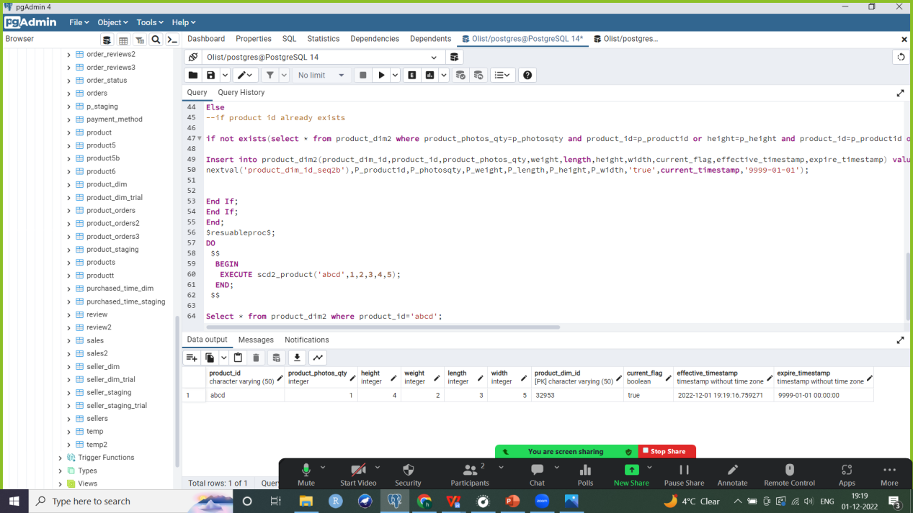

Case 2: Changing 2 values in the record for same product id

--Record with same product id and new values gets inserted with future date as expire ts and current

flag set to ‘true’. Current flag or previous record set to ‘false’ and its expire timestamp is updated to current timestamp

DO

$$

BEGIN

EXECUTE scd2_product('abcd',11,12,3,4,5);

END;

$$

Select * from product_dim2 where product_id='abcd';

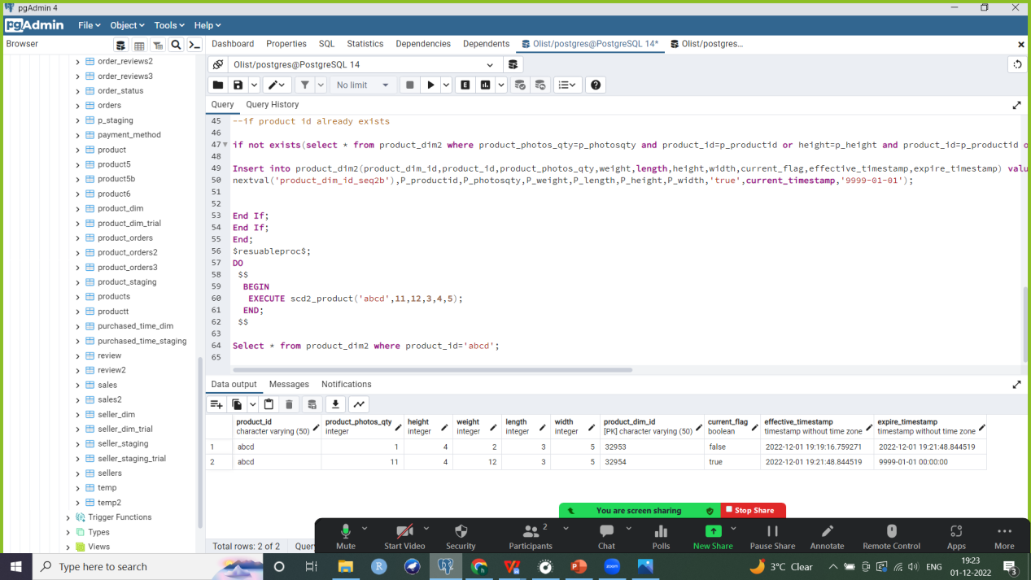

Case 3: Record with same product_id and no updates (i.e. all values remain unchanged)

DO

$$

BEGIN

EXECUTE scd2_product('abcd',11,12,3,4,5);

END;

$$

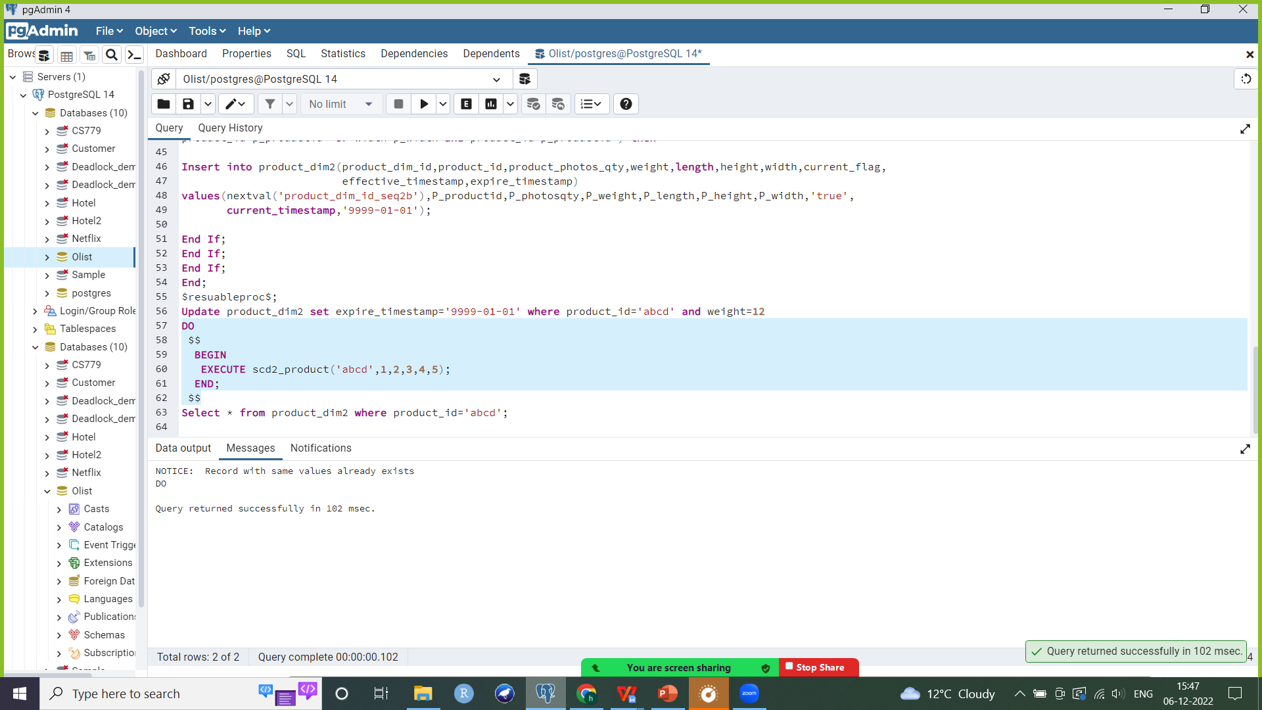

--We get a notice that record with same values already exists in the dimension table.

Select * from product_dim2 where product_id=’abcd’; --dimension table remains unchanged



**Updating fact tables**

I first created dimension and fact tables, and then focused on slowly changing dimensions and how they can be maintained. One hurdle I faced was that since product dimension is scd 2, I added a new synthetic primary key product_dim_id to maintain it. Thus all fact tables which referenced my product dimension table (product_orders and sales) had to be updated to reference product_dim_id as a FK instead of the previous product_id (which can be duplicated in my scd2 product table). I had to update 2 fact tables which had product_id as their FK,PK.

I replaced this with product_dim_id which is the synthetic PK for my product dimension table (since I introduced it to maintain scd2.

--Updating **Review** Snapshot fact table

--Following same steps as before to create review fact table but it now references Product dimension using product_dim_id instead of product_id as FK

CREATE TABLE Review2 as

Select c.customer_id, o.order_id, p.product_id,p.product_dim_id, r.review_score, d.date_id

from Customer_dim c

join Order2 o on c.customer_id = o.customer_id

join Order_items i on i.order_id = o.order_id

join Product_dim2 p on p.product_id = i.product_id

join Order_reviews r on r.order_id = i.order_id

join Date d on d.date_id=r.date_id;

DELETE FROM Review2

WHERE (customer_id,order_id,product_id,date_id) IN

(SELECT customer_id,order_id,product_id,date_id

FROM

(SELECT customer_id,order_id,product_id,date_id,

ROW_NUMBER() OVER( PARTITION BY customer_id,order_id,product_id,date_id

ORDER BY customer_id,order_id,product_id,date_id) AS row_num

FROM Review2) t

WHERE t.row_num > 1 );

--deleting order_id column

alter table review2

drop column order_id;

--deleting product_id column

alter table review2

drop column product_id;

--adding composite PK

ALTER TABLE Review2

ADD PRIMARY KEY (customer_id,product_dim_id,date_id);--composite PK

--adding FK constraints

ALTER TABLE Review2

ADD CONSTRAINT customer_dim_fk2 FOREIGN KEY (customer_id) REFERENCES Customer_dim(customer_id);

ALTER TABLE Review2

ADD CONSTRAINT product_dim_fk2 FOREIGN KEY (product_dim_id) REFERENCES Product_dim2(product_dim_id);

ALTER TABLE Review2

ADD CONSTRAINT date_dim_fk2 FOREIGN KEY (date_id) REFERENCES Date(date_id);

Select * from Review2;

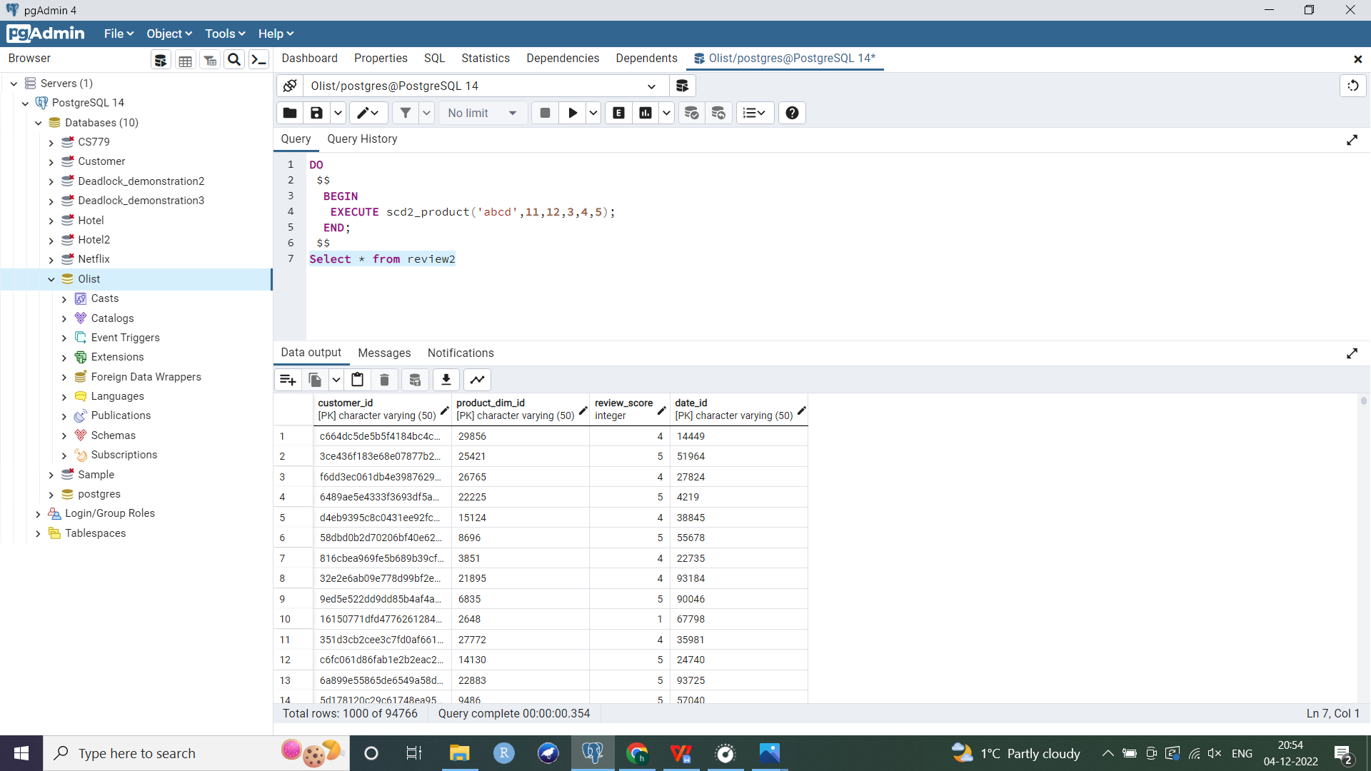

--Updating **Product_orders** fact table

--Following same steps as before to create product_orders fact table but it now references Product dimension using product_dim_id instead of product_id as FK

--Base table

Create table Product_Orders3b as

Select c.customer_id, o.order_id, p.product_id,p.product_dim_id,i.price,pt.purchase_id

from Customer_dim c

join Order2 o on c.customer_id = o.customer_id

join Order_items i on i.order_id = o.order_id

join Product_dim p on p.product_id = i.product_id

join Purchased_time_dim pt on pt.purchase_id=o.purchase_time_id;

--computing average

Create table Product_Orders4 as

Select customer_id,product_id,purchase_id,product_dim_id,avg(price::float) as product_price, count(product_id) as product_qty

from Product_Orders3b

group by customer_id,purchase_id,product_id,product_dim_id;

--Add PK

ALTER TABLE Product_orders4

ADD PRIMARY KEY (customer_id,product_dim_id,purchase_id);--composite PK (with product dim id instead of product id)

--Add FK constraints

ALTER TABLE Product_Orders4

ADD CONSTRAINT customer_dim_fk2b FOREIGN KEY (customer_id) REFERENCES Customer_dim(customer_id);

ALTER TABLE Product_Orders4

ADD CONSTRAINT product_dim_fk2b FOREIGN KEY (product_dim_id) REFERENCES Product_dim2(product_dim_id);

ALTER TABLE Product_Orders4

ADD CONSTRAINT time_dim_fkb FOREIGN KEY (purchase_id) REFERENCES Purchased_time_dim(purchase_id);

Alter table Product_Orders4

Add Column Total_Price float;

UPDATE Product_Orders4

SET Total_Price=product_price * product_qty;

--Dropping product_id and only keeping product_dim_id to reference product dimension

Alter table product_orders4

drop column product_id;

Select * from product_orders4;

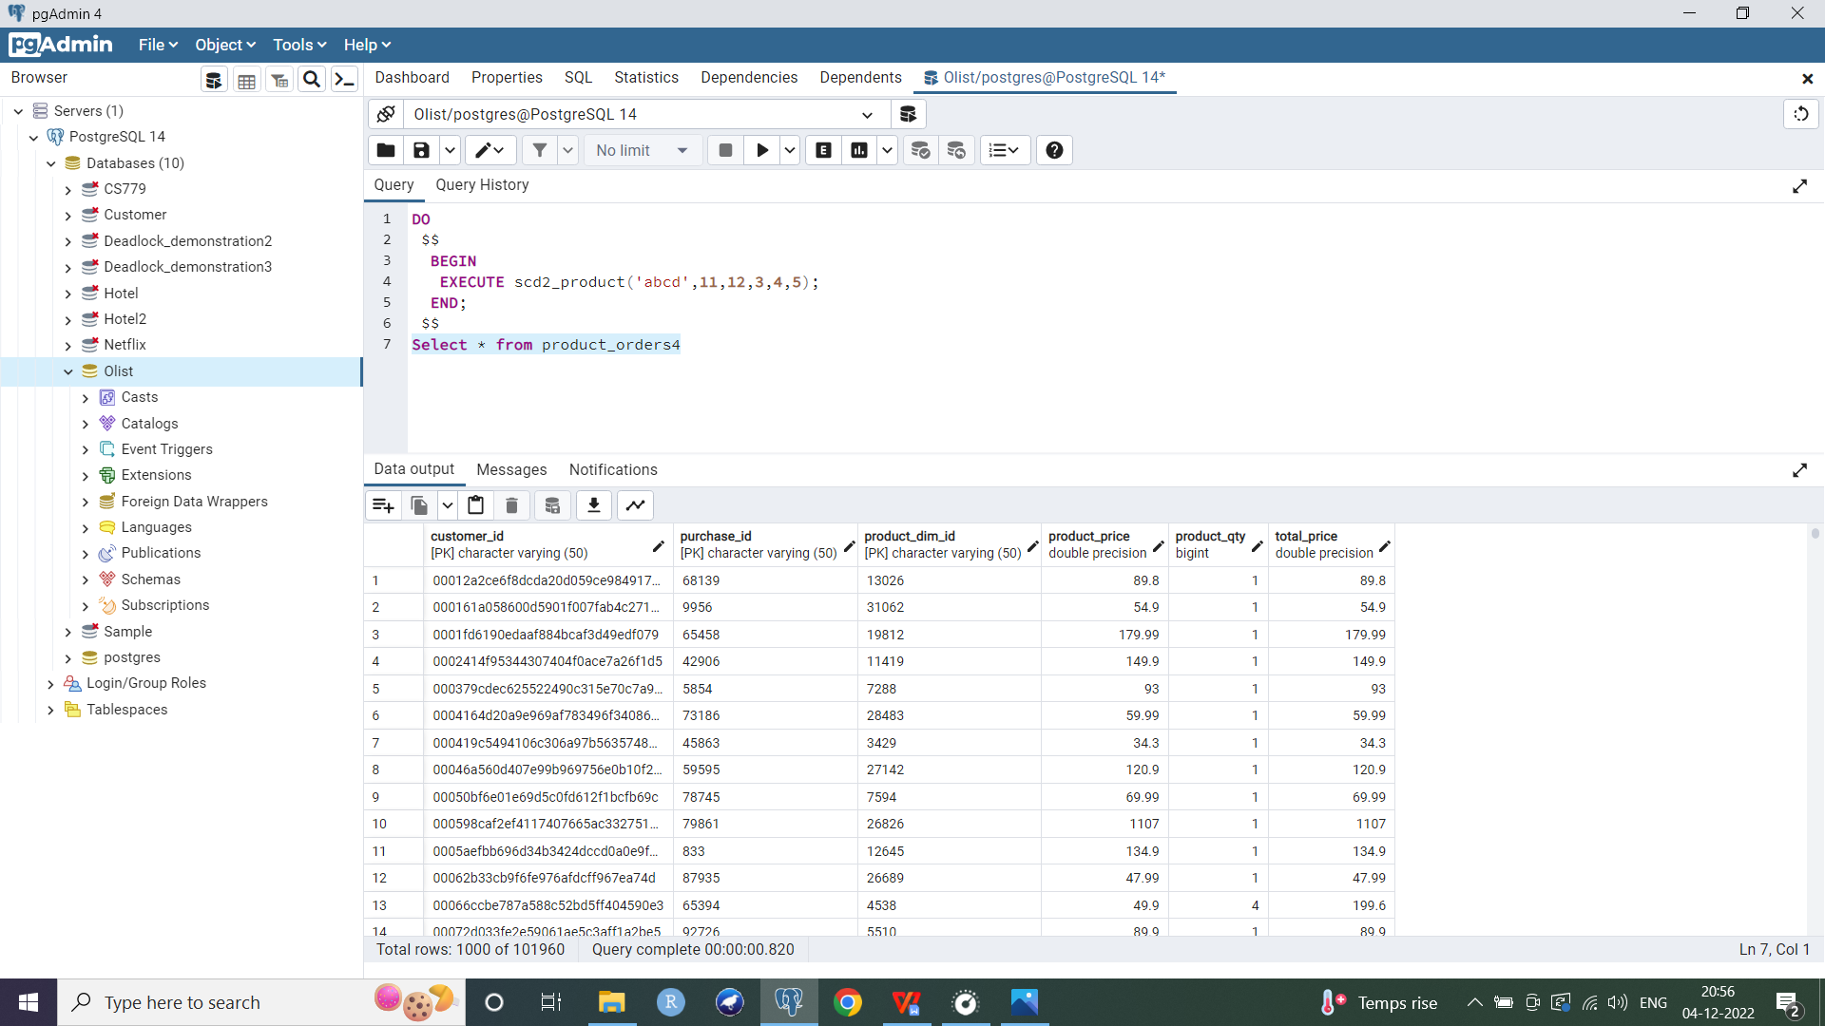

**Indexes**

1. The company often searches for most recent details for each product, thus I created a B-Tree index on the current_flag attribute of the Product dimension table. It can be used to efficiently retrieve records with current flag set as 'true', i.e. most applicable/ latest product details and dimensions. Current flag can be looked up by its index and a pointer to the appropriate rows will help with faster retrieval of the records needed.

CREATE INDEX product_current

ON product_dim2 (current_flag);

1. I implemented a B-Tree index on the purchase_quarter attribute of the Purchased_time dimension which is queried frequently. It can be used to quickly retrieve data only for a certain quarter. For example, we can join the purchased_time_dim and product_orders fact table to get sales and revenue in a particular quarter efficiently, eliminating the need for a full table scan.

CREATE INDEX purchasedtime_quarter

ON purchased_time_dim (purchase_quarter);

1. I used a multicolumn index for state and city attributes of the Customer dimension table. Here state is more often used for lookups or in the WHERE clause (for example, to look at sales and revenue earned per state) hence it is placed at the beginning of the column list while defining this B-Tree index.

CREATE INDEX customer_address

ON customer_dim (customer_state,customer_city);

If we search for sales or revenue per state or for a city in a particular state (by joining customer_dim dimension table and product_orders fact table), this index will be used to efficiently scan through the table and retrieve relevant records quickly. However if we search only on the city (i.e. where condition only looks for sales/revenue in a particular city), this index will not be applicable and a full table scan will be used.

Ideally, since current_flag, customer_state and purchase_quarter are attributes with low cardinality (more repeating values), a Bitmap index would be useful. Moreover, Bitmap indexes are more suitable for decision support systems. However Postgresql does not support bitmap indexes, hence I have used a B-Tree index here.

**Business questions**

* Finding out the highest selling product category as well as identifying under performing product categories in order to make informed decisions on which products should be dropped or marketed more.
* Finding out which quarter had the highest revenue to understand what factors contributed to a higher earning in that quarter (for example, quarter 2 could have a higher revenue because of summer sales). Further looking at top 10 best selling product categories in this highest earning quarter to make business decisions on marketing these products during peak season.
* Observing trend in total revenue across all 3 years the company has data for (2016 to 2018).
* Analyzing average review scores per month. This can be used to understand customer sentiments throughout the year (for example, checking if ratings are higher during the holiday season, etc.).
* Analyzing average review scores per quarter across all 3 years. For example, if the company launched a new product, it might be useful to look into ratings during this period.
* Inspecting total earnings per product category by sellers across all cities to identify best selling product categories from each city (i.e. sellers from a particular city had highest revenue for which product category) as well as examine where each product category is most popular or which city houses the highest earning sellers for a given category of products (sellers from which city earned most from sales of this product category). This could be useful for investing in courier/delivery services to high performing geographical locations.
* Evaluating how sellers from various states are performing and which state houses the best sellers. Further understanding products of which category are most popular from sellers of various states. This can be used to reward the top performing seller states by providing incentives such as hosting a conference in that state, etc.
* Observing if there is an association between the number of product photos that a company has put up on their website and product ratings. For example, higher number of photos leading to higher expectations by the customer, thus leading to a lower rating. This can then be used to increase or decrease the number of product photos.
* Examining the revenue and number of products sold/ sales per month, and analyzing if these measures are correlated. For example, does the price of each product play a greater role than the number of products sold in contributing toward total revenue?
* Identifying geographical areas which are generating the highest revenue. This can be helpful in implementing location based advertisement strategies.

**Tableau Analysis**

* Beleza saude (or beauty health) was the highest selling product category. Seguros e servicos (insurance and services) was the lowest selling product category.
* Quarter 2 was the highest earning quarter. In this quarter, cama mesa banho (or bed table bath) was the best selling product category, followed by beleza saude (beauty health).
* 2017 saw a steady rise in revenue. Earnings were quite high and remained consistent for most part of 2018 except a sudden drop in September.
* Product ratings were highest in July (average of 4.26), followed by August and September.
* Product ratings were consistently higher in 2017 as compared to 2016 and 2018. Both in 2017 and 2018, quarter 3 had highest product ratings.
* To analyze revenue per product category by sellers from various states, I used the top 5 states and top 5 product categories (based on total revneue) for the purpose of my visualization. We can see from the grouped barplot that sellers from Curitiba (Cu) and Ibitinga (Ib) were most popular/ had highest earnings for moveis decoracao (or furniture decoration). Similarly, best selling product category by sellers from Rio de janeiro (Rdj) was brinquedos (or toys). We can also say that Sau paulo (Sp) had the highest earning sellers for brinquedos/ toys and esporte lazer (or sport leisure), and so on.
* Sellers from Sau Paulo (SP) state had highest number of sales. These sellers were most popular for cama mesa banho (or bed table bath) products. The next best sellers were from Minas Gerais (MG) and their sales were highest for informatica acessorios (or computer accessories).
* The number of product photos the company uploads does not seem to have an impact on customer ratings.
* Revenue was highest in the month of May, followed by August. On the other hand, number of sales were highest for August, followed by May. Could increasing product prices in August further increase revenue during this month?
* Highest revenues were generated by PR (Parana) and SC (Santa Catarina).

**References**

1. https://aws.amazon.com/blogs/big-data/implement-a-slowly-changing-dimension-in-amazon-redshift/
2. https://www.timescale.com/blog/postgresql-vs-python-for-data-cleaning-a-guide/
3. https://www.postgresql.org/docs/current/functions-datetime.html
4. https://www.postgresqltutorial.com/import-csv-file-into-posgresql-table/